Long-term Changes in the Pocono Lakes: An interactive web-based app to explore a long-term lake data set

Overview:
Limnological data on three small but trophically diverse lakes in the Pocono Lakes region of northeastern Pennsylvania, USA, have been collected over the past three decades, with high frequency data added to this data set in more recent years. This app gives the user the ability to access and easily visualize trends in this data set. Through user-selected controls, the app will instantly generate plots and summary statistics of these data, using variables selected by the user. The selected data can then also be downloaded, allowing for further exploration by the user. The long-term data used by the app are openly available and regularly updated through EDI’s (Environmental Data Initiative) data repository. This introduction to the app serves as a resource for users, allowing them to access the app and explore the data with guidance from the developers.

The app:
This app can be accessed via https://dataviz.miamioh.edu/PennsylvaniaLakes/. Upon opening the app, 5 pages are available to explore this data set, “Lakes”, “Variables”, “Abiotic”, “High-Frequency”, and “Zooplankton”. Descriptions of each follow, including annotated screenshots of portions of the app.

- Lakes
This first page provides general information regarding the three lakes featured in this app: Lacawac, Giles, and Waynewood. Location and limnological characteristics of the lakes are summarized, and supporting publications are listed (Figure 1).
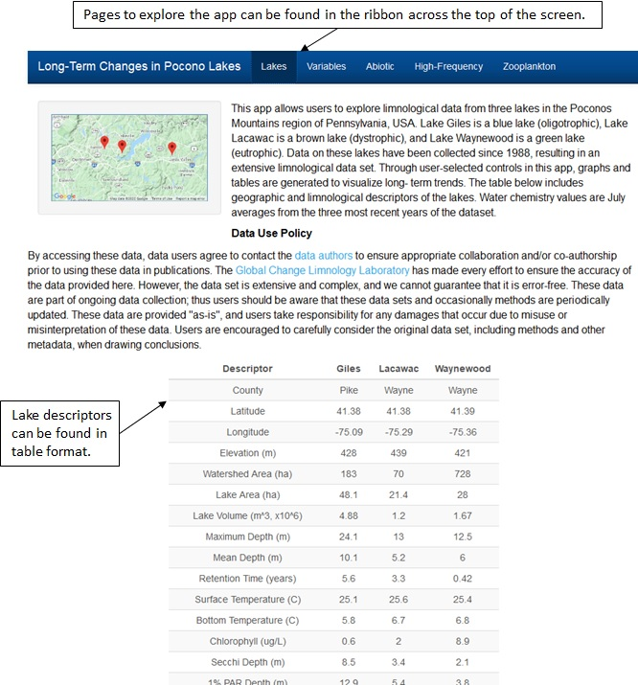
Figure 1: Labeled image showing the “Lakes” page of the app.

- Variables
Variables that are available for user-selection in this app are defined here (Figure 2).
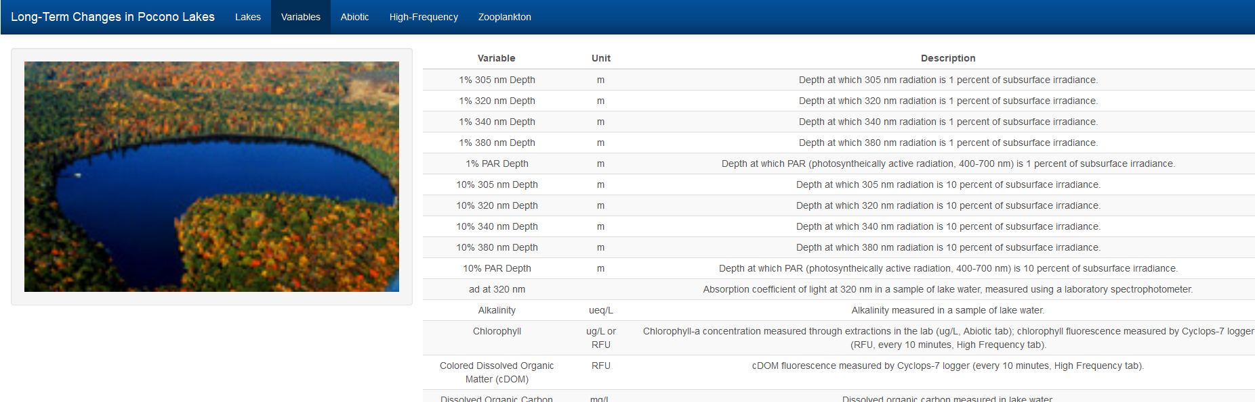
Figure 2: Image showing the “Variables” page of the app. Variables available for selection within the app are described in this table.

- Abiotic
This page summarizes the long-term abiotic data, with values presented as summer averages (May-August). These data were collected when the lake was stratified, and variables which were measured at multiple depths can be viewed by lake layer (Figure 3).
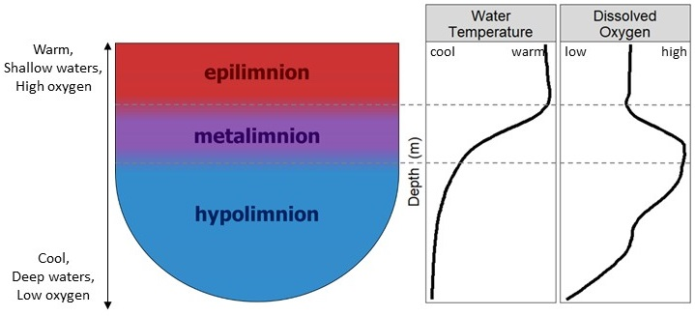
Figure 3: These lakes are thermally stratified during the summer months, when samples were taken. The epilimnion consists of well-mixed warm, highly oxygenated waters, with uniform temperature and oxygen levels. In the metalimnion (thermocline) temperature and oxygen levels decrease with depth. Waters in the hypolimnion are cool and typically have low oxygen levels, including at times anoxia, a total lack of oxygen.

In this tab, there are 2 sub-panels: “Graph” and “Table”. The Graph panel displays a scatterplot of the time-series data points with a simple linear trend line fit to the data. Statistics below the graph shows the results of a Mann-Kendall nonparametric trend test which indicates both the direction (indicated by direction of Sen’s slope and Kendall tau) and strength of the trend (indicated by magnitude Kendall tau, ranging from -1 to 1). Significant trends (p < 0.05) are denoted by a solid black trend line. A dashed trend line indicates a non-significant trend (p > 0.05). Below the scatterplot is the table with statistical output for the selected variable at the specified lake and, if applicable, depth layer. These statistics include Kendall tau, number of years over which data were collected, p-value, and Sens Slope (Figure 4).
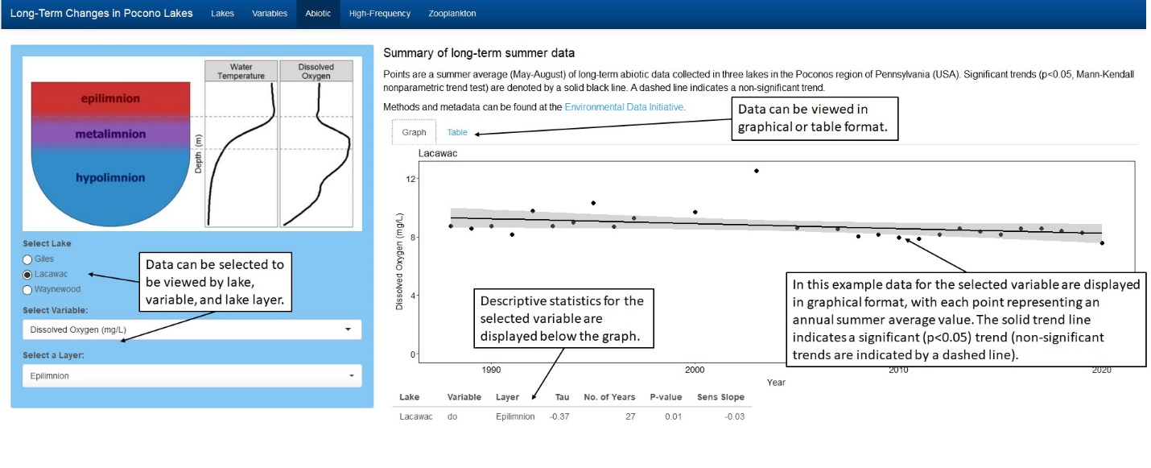
Figure 4: Labeled image showing the “Abiotic” page in the app. In this example, dissolved oxygen data from the epilimnion are displayed in graphical form.

The “Table” sub-panel shows the yearly summer-averaged data that were used to generate the scatterplot. This sub-panel has a search box on the right so users can search for specific keywords or values, as well as a download option to save data to your local computer (Figure 5).
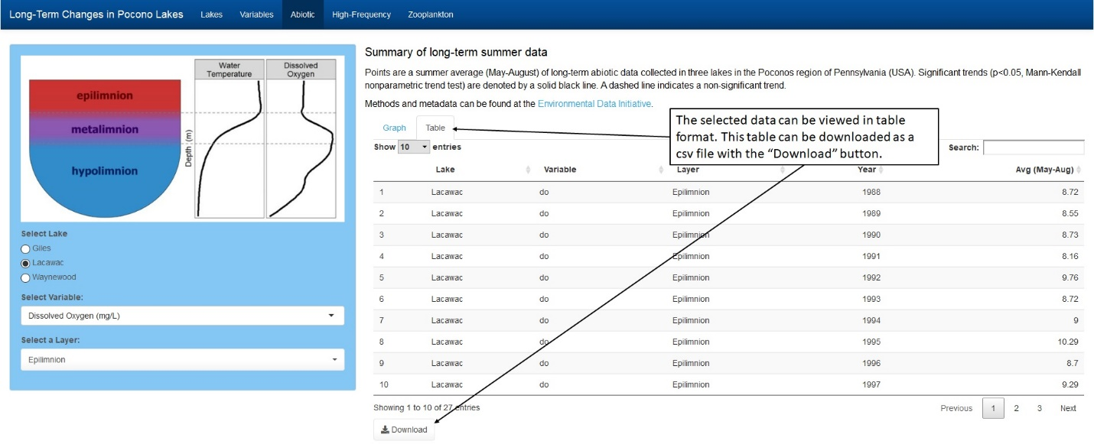
Figure 5: Labeled image showing the data table view of the “Abiotic” page in the app. In this example, the values used to generate the dissolved oxygen graph in Figure 4 are displayed.

The variables available for selection in the “Abiotic” page are defined in the following table:
Variable | Units | Description
Dissolved Oxygen (DO) | mg/L | DO measured in situ. Data can be viewed by layer of the lake.
Alkalinity | ueq/L | Alkalinity measured in lake water. Data can be viewed by layer of the lake.
Chlorophyll | ug/L | Chlorophyll concentration in lake water, measured through extractions in the lab. Chlorophyll concentration can be indicative of primary productivity (algae levels). Data can be viewed by layer of the lake.
Total Phosphorus (TP) | ug/L | TP concentration in lake water. TP is determined by measuring all phosphorus forms in a sample of lake water. Phosphorus is essential for phytoplankton growth, thus higher TP levels can indicate higher lake productivity. Data can be viewed by layer of the lake.
Dissolved Organic Carbon (DOC) | mg/L | DOC concentration in lake water. DOC results from the breakdown of organic materials in water, and results in coloration of the water. Data can be viewed by layer of the lake.
ad at 320 nm | per meter | Absorption coefficient of light at 320 nm in a sample of lake water using a spectrophotometer. Data can be viewed by layer of the lake.
SS 275-295 nm | per nanometer | Spectral slope between 275 and 295 nm measured in a sample of lake water using a laboratory spectrophotometer. Data can be viewed by layer of the lake.
Temperature | degrees C | In situ temperature of lake water. Data can be viewed by layer of the lake.
Total Nitrogen (TN) | mg/L | TN concentration in lake water. TN is determined by measuring all nitrogen forms in a sample of lake water. Nitrogen is essential for phytoplankton growth, and thus levels can be related to lake productivity. Data can be viewed by layer of the lake.
pH | pH units | pH of lake water. Data can be viewed by layer of the lake.
Secchi Depth | m | Secchi depth of the lake is indicative of water clarity, with a greater depth indicating greater water clarity. Secchi depth is measured by lowering/raising a black and white disk through the water column and recording the depth at which the disk disappears/reappears.
10% 305 nm Depth | m | Depth at which 305 nm solar radiation is 10% of subsurface value. A greater value indicates greater penetration of 305 nm radiation through the water column.
10% 320 nm Depth | m | Depth at which 320 nm solar radiation is 10% of subsurface value. A greater value indicates greater penetration of 320 nm radiation through the water column.
10% 340 nm Depth | m | Depth at which 340 nm solar radiation is 10% of subsurface value. A greater value indicates greater penetration of 340 nm radiation through the water column.
10% 380 nm Depth | m | Depth at which 380 nm solar radiation is 10% of subsurface value. A greater value indicates greater penetration of 380 nm radiation through the water column.
10% PAR Depth | m | Depth at which PAR (photosynthetically active radiation) is 10% of subsurface value. A greater value indicates greater penetration of PAR through the water column. PAR consists of the solar wavelengths used for photosynthesis.
1% 305 nm Depth | m | Depth at which 305 nm solar radiation is 1% of subsurface value. A greater value indicates greater penetration of 305 nm radiation through the water column.
1% 320 nm Depth | m | Depth at which 320 nm solar radiation is 1% of subsurface value. A greater value indicates greater penetration of 320 nm radiation through the water column.
1% 340 nm Depth | m | Depth at which 340 nm solar radiation is 1% of subsurface value. A greater value indicates greater penetration of 340 nm radiation through the water column.
1% 380 nm Depth | m | Depth at which 380 nm solar radiation is 1% of subsurface value. A greater value indicates greater penetration of 380 nm radiation through the water column.
1% PAR nm Depth | m | Depth at which PAR (photosynthetically active radiation) is 1% of subsurface value. A greater value indicates greater penetration of PAR through the water column. PAR consists of the solar wavelengths used for photosynthesis.
Kd 305 nm | per meter | Diffuse attenuation coefficient of light at 305 nm measured in situ with a profiling radiometer. Kd is measured as the change in light attenuation with depth, with a greater value indicating a greater decrease in penetration with depth.
Kd 320 nm | per meter | Diffuse attenuation coefficient of light at 305 nm measured in situ with a profiling radiometer. Kd is measured as the change in light attenuation with depth, with a greater value indicating a greater decrease in penetration with depth.
Kd 340 nm | per meter | Diffuse attenuation coefficient of light at 340 nm measured in situ with a profiling radiometer. Kd is measured as the change in light attenuation with depth, with a greater value indicating a greater decrease in penetration with depth.
Kd 380 nm | per meter | Diffuse attenuation coefficient of light at 380 nm measured in situ with a profiling radiometer. Kd is measured as the change in light attenuation with depth, with a greater value indicating a greater decrease in penetration with depth.
Kd PAR | per meter | Diffuse attenuation coefficient of PAR (photosynthetically active radiation) measured in situ with a profiling radiometer. Kd is measured as the change in light attenuation with depth, with a greater value indicating a greater decrease in penetration with depth.

Depth-specific data can be viewed by lake layer. Lakes such as these typically stratify during the summer months into three layers, as follows (also Figure 3):
Layer | Description
Epilimnion | Upper stratum of the lake. Water is well-mixed resulting in consistent temperature and dissolved oxygen levels throughout this layer.
Metalimnion | Middle stratum of the lake (thermocline). In this layer water is stratified, with temperature and dissolved oxygen decreasing with increasing depth.
Hypolimnion | Bottom stratum of the lake. This layer extends from the bottom of the metalimnion to lake bottom. Temperature and dissolved oxygen are consistent throughout this layer, and typically low, at times experiencing anoxia.

- High-Frequency
Data collectors, including miniDOT, miniPAR, and Cyclops-7 (chlorophyll and DOM) sensors, were deployed underwater to collect high-frequency data. These data collectors are sensors designed to collect high frequency data unattended. Further descriptions of each can be found at their websites, hyperlinked above under each collector’s name.
High-frequency data collected by these sensors are displayed on this page. This page is designed similarly to the previous “Abiotic” page, with options to select the lake, variable, and depth from which to display data (Figure 6). Data have been aggregated here to present daily values. Data are displayed graphically, and data used to generate line graphs can be downloaded using the “Download Data” button. Upon choosing a lake and variable to display, the graph panel will show a line plot where each line represents a different depth.
Some variables such as water temperature and dissolved oxygen have many depths with available data. Upon selecting these variables, the user will be asked to select which depths to view. Multiple depths can be selected to display at one time. To remove a depth, simply select the depth and press Delete on the keyboard. There is also an option to download the data set as a csv file.
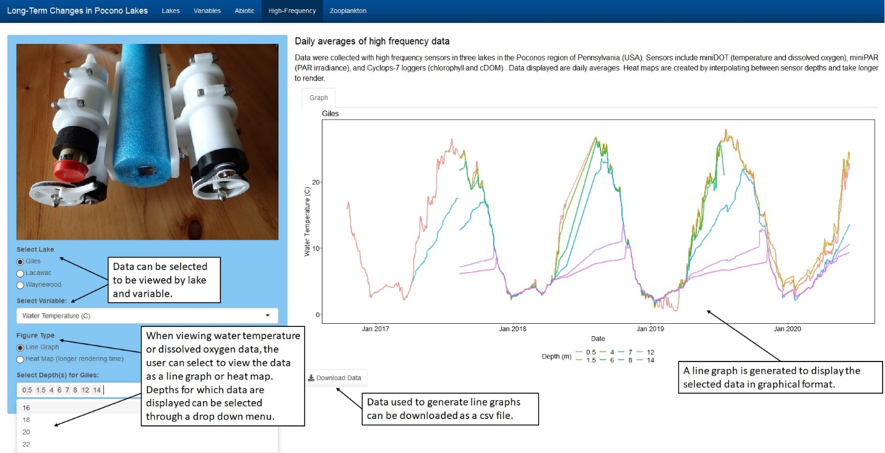
Figure 6: Labeled image showing the “High-Frequency” page in the app, with data displayed as a line graph.

Water temperature and dissolved oxygen data can also be viewed as heat maps, which can be selected under “Figure Type”, with values represented by a color gradient across depth and time. Heat maps are generated by interpolating between sensor depths. These figures take longer to render and there is no option to download data, as values are interpolated between sensor depths (Figure 7).
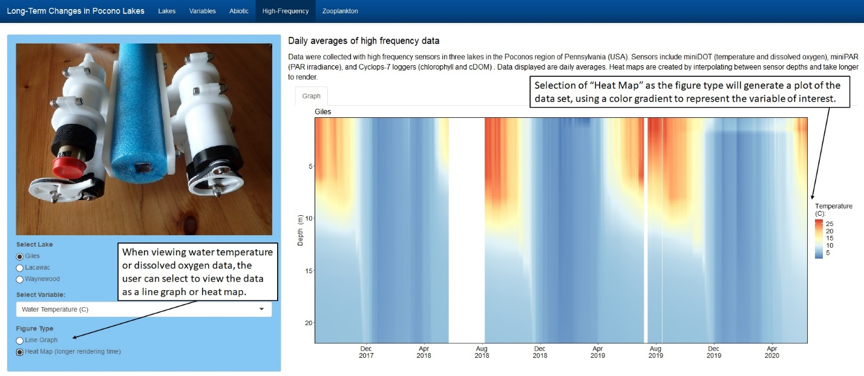
Figure 7: Labeled image showing the “High-frequency” tab in the app, with data displayed as a heat map.

The variables available for selection in this tab are defined in the following table:
High-Frequency
Variable | Units | Definition
Chlorophyll | RFU | Chlorophyll was measured in situ in relative fluorescence units (RFU) in the upper stratum of the lake. Chlorophyll concentration can be indicative of primary productivity (algae levels).
Colored Dissolved Organic Matter | RFU | Dissolved organic matter was measured in situ in relative fluorescence units (RFU) in 2 locations in the water column, a location in the upper stratum and near the lake bottom. This value is indicative of water color due to organic matter, which affects water transparency.
PAR | umol/s/m2 | PAR (photosynthetically active radiation) was measured at two depths in the upper stratum of the lake. PAR consists of the solar wavelengths used for photosynthesis.
Kd PAR | per meter | Diffuse attenuation coefficient (Kd) of PAR (photosynthetically active radiation) is measured as the change in light attenuation with depth, with a greater value indicating a shallower penetration (lower transparency).
Water Temperature | degrees C | Water temperature at selected depths throughout the water column.
Dissolved Oxygen | mg/L | Dissolved oxygen at selected depths throughout the water column.

- Zooplankton
This page represents a summary of long-term summer zooplankton data from the three lakes (Figure 8). Data are available beginning in 1990. Statistics are based on a Mann-Kendall nonparametric trend test. These data can be displayed by lake as a monthly value or a summer (May-August) average. The user can select to view the data by zooplankton group or genus, and as abundance (organisms/L) or proportion in epilimnion (abundance in epilimnion/ abundance in entire water column). The graphical and tabular displays are similar to the “Abiotic” tab, with a statistical output table below the scatterplot and a second “Table” panel to view and download the summarized data used to generate the scatterplot and statistics. The scatterplot smoother line denotes whether or not the Mann-Kendall test was significant (p<0.05, solid black line) or not (p>0.05, dashed grey line).

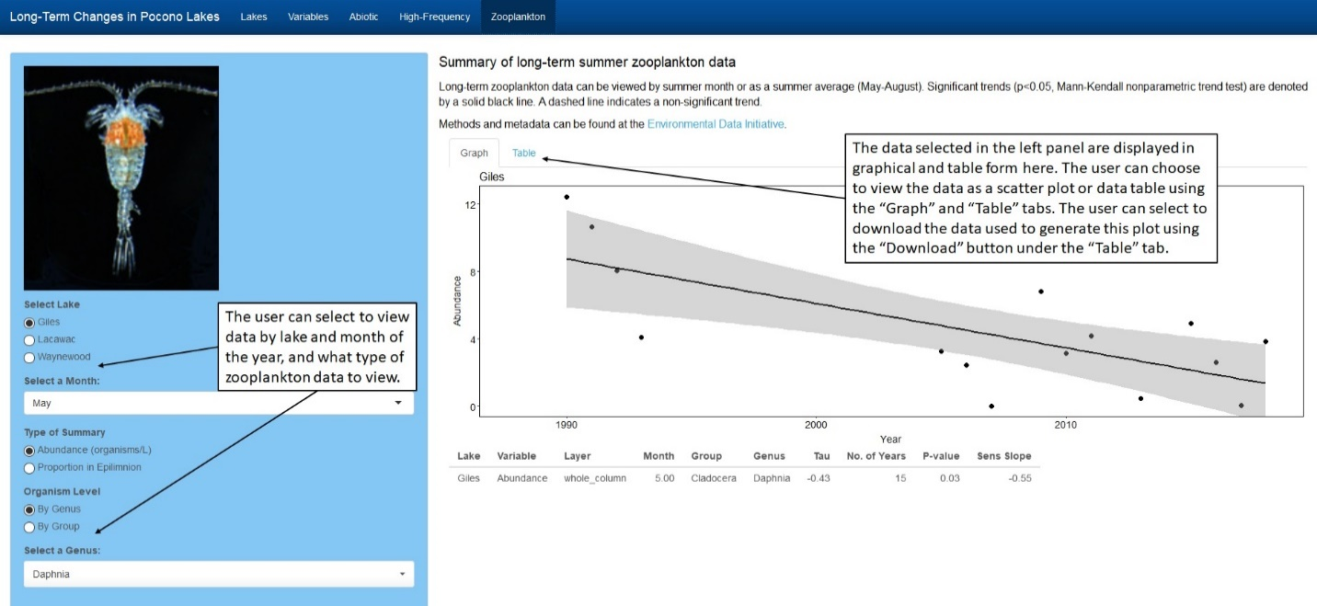
Figure 8: Labeled image showing the “Zooplankton” page in the app.

The zooplankton included in this data set are as follows:
Zooplankton
Genus/ Group | Taxonomic Group | Sample Image | Genus/ Group Description
Daphnia | Cladoceran | 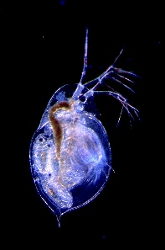 | Daphnia are a member of the Cladoceran order. They are filter feeders, consuming phytoplankton (algae), and are preyed upon by small fish.
Gastropus | Rotifer | 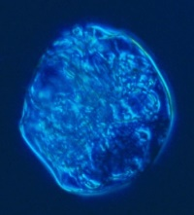 | Gastropus is a small, soft-bodied zooplankton in the phylum Rotifera. It consumes phytoplankton, and is preyed upon by larger zooplankton.
Kellicottia | Rotifer | 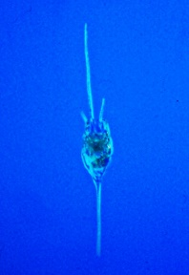 | Kellicottia is found in the phylum Rotifera. As a small zooplankton, it is preyed upon by larger zooplankton, but its large spines help to protect it from predation.
Keratella | Rotifer | 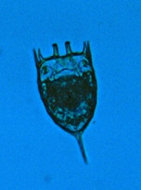 | Keratella are small zooplankton (rotifers) that consume phytoplankton and are preyed upon by larger zooplankton. However, its spines do help to protect it from predation.
Polyarthra | Rotifer | 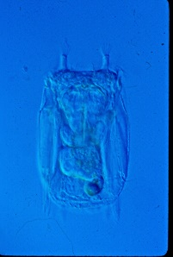 | Polyarthra are small zooplankton in the phylum Rotifera. They use their fins to jump very rapidly and escape predators.
Calanoid copepod | Copepod | 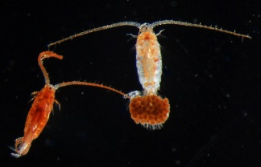 | Calanoid copepods are small crustaceans from the sub-class Copepoda. They prey upon phytoplankton and smaller zooplankton, and are consumed by small fish.
Cyclopoid copepod | Copepod | 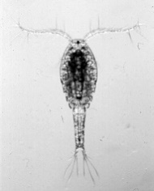 | Cyclopoid copepods are small crustaceans from the sub-class Copepoda. Members of this group have shorter first antennae compared to calanoid copepods. They are grasping feeders, enabling them to eat larger prey than calanoids, in general.
Nauplii | Copepod | 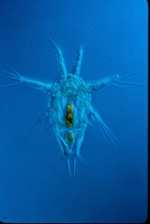 | Nauplii are the larval forms of Calanoid and Cyclopoid copepods. They feed upon smaller organisms, including phytoplankton, and are consumed by small fish as well as other copepods.

