Title:
Using Soil Fungi Next Generation Sequencing Data to Study Wildfire Resiliency

Author(s):
Savanah Senn, MS, PhD, CQIA^{1,2}
¹Plant Science Program
Agriculture Sciences Department
Los Angeles Pierce College
Woodland Hills, CA 91371
²Environmental Sciences Graduate Program
Oregon State University
Corvallis, OR 97331
stclais@piercecollege.edu

Abstract:
How can we engage students to look deeper into life in the soil? How are fungal communities associated with post wildfire resiliency? The Pierce College Plant Science program has developed a course-based undergraduate research project for Soil Science students. Faced with the challenges of COVID-19 emergency remote education, the project was adapted to an online environment. This lab exercise is an active learning introduction to techniques used to analyze soil microbiome data. Students will also learn about forming hypotheses, what kind of questions can be answered with this data, and scientific method.
Considering more open-ended questions and experiments fosters innovation and welcomes diverse points of view. UC CalEDNA (University of California Environmental DNA program) provides low-cost kits and sequencing and hosts Ranacapa (Kandlikar 2021). This activity has been tested in a lower division undergraduate general education science live zoom online course. It may be appropriate for plant science, soil science, ecology, or forestry related courses. This exercise engages students in cutting edge data analysis by connecting the molecular ecology of soils to current events that affect our daily lives.

Introduction
This lab exercise is an active learning introduction to techniques used to analyze soil microbiome data. Students will also learn about forming hypotheses, what kind of questions can be answered with this data, and practice the scientific method. This activity may be appropriate for plant science, soil science, ecology, or forestry related courses. The aim of this exercise is to engage students in cutting edge data analysis by connecting the molecular ecology of soils to current events that affect our daily lives.
According to the National Research Council, student activities in the lab should reflect what scientists actually do (Singer et al 2012, Banta et al 2017). Rather than taking the more traditional approach of canned labs, this activity uses a project-based curricular design in order to attract, train, and retain more diverse students in STEM fields. Early research experience in undergraduate classes is a strategy for increasing persistence of STEM majors in under-represented groups (Toven-Lindsay 2015). Considering more open-ended questions and experiments fosters innovation and welcomes diverse points of view.
Teaching metabarcoding is a great way to bring NGS research and basic bioinformatics into the classroom. Some of the benefits of working with this technique are that it is relatively low cost and going from sampling to data can be achieved within a semester. This technique involves extracting the global environmental DNA from a substrate such as soil. Then microbial sequences are amplified using PCR, in this case the fungal internal transcribed spacers (FITS markers). Finally, the amplicons are sequenced and processed using software such as QIIME2 and sequence variants are identified using a database of known organisms. The organisms are then tested for differences based on categories or data as physical or chemical properties of soil, the type of plant host, or in this case, the fire history of the samples. These data may be collected in the field, or may be determined by historical data such as USDA Web Soil Surveys. In this proposed activity, students will work with USDA historical metadata a published fungi metabarcoding dataset. In this study, the researchers were particularly interested in assessing which environmental factors were most correlated with microbial diversity (Senn 2022). This is a peer reviewed original research article published in a journal with a strong impact factor, and indexed on NCBI PubMed. Collaborators on this study included researchers from Los Angeles Pierce College, Oregon State University, James Madison University, and Cold Spring Harbor Laboratories.
Following wildfire, there are a cascade of effects as the forest comes back to life. These include sprouting of seeds stored in the soil, colonization by fungi of burned plant matter, and the liberation of oily and aromatic compounds from soil and plant matter. For example, tree poppy seeds are scarified by fire which encourages them to germinate, and Thick-leaf Yerba Santa reproduces by rhizomes and spreads more efficaciously following fire (CalFlora). Since there is less plant material available, there is more competition for food. Yerba Santa can be browsed by deer in the winter (USDA Forest Service). In addition, the flowers are visited by a variety of bees including Bombus and honey bees (USDA Forest Service). The 2016 Sand fire was caused by extreme heat, ongoing drought, and dry vegetation. Humans may have caused fires to occur more frequently.
Many plants and fungi produce alkaloids and anti-herbivory compounds, and these toxins can be released during a burn (Laskin et al 2009). Plants depend on the nutrient cycling capabilities of saprobes who break down organic matter; these fungi may be killed during a burn (U.S. Forest Service). Fungi are also known to produce an array of antibiotics, accounting for about 40% of the antibiotics discovered from microbes (Demain 2017). This activity is about taking a look at the differences in fungi composition between three different fire areas in the Angeles National Forest.

Table 1. The learning objectives for the activity show what the student will be able to do after completing the activity.
Learning objectives:
- Become familiar with the soil separates, sand, silt, and clay, and the organic matter component of soil and how these parameters may affect pH and CEC (cation exchange capacity).
- Properly document percentages.
- Synthesize soil data from a national database and create a table in Excel.
- Think critically about the factors that may influence soil microbe composition and function in plant rootzones.
- Understand and apply basic statistical concepts related to mean, variance, and genetic distance.
- Understand and apply exploratory alpha and beta diversity analyses.
- Interpret boxplots, relative abundance stacked barplots, abundance heatmaps, adjusted p-values, and Principal Coordinates Analysis (PCoA) plots.
- Form a hypothesis about how fire history may be influencing soil fungi abundance based on the preliminary results.
Timeframe:
Two 2-hour remote or in-person lab sessions (4 hours total). In the first lab session, students will learn to use the USDA web soil survey to collect soil physical and chemical properties data. In the second session, students will be introduced to working with Next Generation Sequencing (NGS) data. Instructors should preview the activity in order to prepare, with an estimated prep time of 1 hour to run through the activity.

List of materials:
The applications used in the activity, which are the Ranacapa shiny app and the USDA Web soil survey, do not need to be installed on a hard drive. For that reason, they can be run on a PC or a Chromebook. The activity also uses Microsoft Excel, which students may have access to through their student institutional accounts. They may also choose to use Google sheets, Libre, or Apple Numbers. The amount of flexibility in that regard is up to the instructor and the facilities available. The first part of the activity, which involves finding historical soils data from the location of the experiment (Werts 2021), has been tested asynchronously in online classes. However, the second part of the activity involving the soil microbiome is recommended to be carried out live in a group with in-person instruction or using live conferencing such as zoom breakout room discussions. It also works as a large group discussion where students can share their results.

Procedure and general instructions (for instructor).

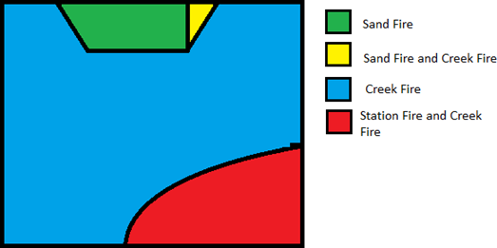
Figure 1. Schematic map of the fire history of the trail areas at the Gold Creek Preserve, Angeles National Forest. The Red Trail had recent fires with the highest intensity, the Green Trail was subject to medium intensity fires, and the Blue Trail had a recent low intensity fire.
The Web Soil Survey provides a brief technical description of the values, such as as pH and CEC, and how they were measured, which acquaints users with basic soil terminology. The Ranacapa shiny web app (Kandlikar 2021) interface teaches the diversity analyses to the user by providing an introduction and additional resources, making it a suitable tool for users with limited experience.
Students will need a basic introduction to the taxonomic ranks in the Linnean classification system, i.e., Kingdom, Phylum, Class, Order, Family, Genus, Species. Students should also be familiar with a few examples of the Ascomycota such as water molds and yeasts, and Basidiomycota such as mushrooms and mycorrhizae. An internet connection and access to a PC or Chromebook is required. Students will benefit from being introduced to the data science concepts in Table 2 prior to attempting part II of the activity. Some things to look out for include students swapping the positions for metadata and taxonomy tables during the initial load or forgetting to select a variable or taxonomic level on the upper right hand side when attempting to compare plots. In other words, the students must select a variable to test or a level on which they will compare the sites.
The limitations of the study involve the lack of unburned control and the number of potential environmental factors contributing to the observed microbial diversity. Nevertheless, taking this type of genomic research out into the field takes research questions beyond laboratory microcosms and looks for answers in the environment where the phenomenon is occurring. This activity provides an opportunity for students to think about experimental design, and also to consider what other factors may have contributed to the soil microbial diversity.

Table 2. Key Definitions for the Lab Activity to be Presented by the Instructor
Type of data | An OTU (Operational taxonomic unit) table which is a data frame of counts. The columns are samples and the rows represent different taxa. The numbers in each cell represent the number of times the sequence for that taxon was identified in each sample.
Metadata | The data about the data. The metadata typically includes measurable characteristics of the site. Without metadata, the sequencing data is not usable.
Replication | Multiple samples are collected for each condition or category in this site. This allows for a computation of error and allows the investigator to capture more diversity. In this study, at least 3 samples were collected from each Trail. Each individual sample was comprised of 3 subsamples from within a 3-foot radius. Then, the three subsamples were bulked after DNA extraction. Therefore, although 20 data points are shown, 60 samples total were collected from the Preserve.
Mean | average
Standard deviation | a measure of variability for how far sample values fall outside of the mean.
Standard error | a measure of variability that takes into account the sample size, which is the total number of samples in the experiment.
p- value | The probability that results could be just as extreme by chance alone. Takes on a value between 0 and 1. Common cutoffs used for significance are 0.01 and 0.05. A value of 0.10 is considered marginally significant.
Boxplot | a type of plot that allows you to compare values based on their mean and standard error to detect significant differences. This is also sometimes called a box and whisker plot. The mean is plotted in the center of the box and the standard errors are plotted about the mean.
Distance matrix | a matrix of values that shows how genetically different or distant the samples are from one another.
Principal Coordinates Analysis | a visual model that depicts a distance matrix; the purpose is to see how similar or dissimilar the samples are from one another. More similar samples are depicted near to one another and dissimilar samples will be more distant from one another.

Additional Background Information/ Suggested Reading:

The instructor may wish to review some of the topics below, or assign them to students for reading prior to the activity.
Soil Chemical and Physical Properties
Edward Plaster. Soil Science and Management. Chapter 4 Physical Properties of Soil, Chapter 11 Soil Chemistry. 6th Edition. Cengage, 2013.
Next Generation Sequencing Educational Resources
Bethany Bowling, Erin Zimmer and Robert E. Pyatt. 2014. Bringing Next-Generation Sequencing into the Classroom through a Comparison of Molecular Biology Techniques. The American Biology Teacher, 76(6):396-401. http://www.bioone.org/doi/full/10.1525/abt.2014.76.6.7
Hartman, Mark R., et al. "Personal microbiomes and next-generation sequencing for laboratory-based education." FEMS Microbiology Letters 363.23 (2016). https://doi.org/10.1093/femsle/fnw266
Illumina, Inc. A beginner’s guide to NGS. 2022. https://www.illumina.com/science/technology/next-generation-sequencing/beginners.html
Trophic Cascades and Ecosystem Services
Kyle A. Emery, Jessica A. Gephart, Grace M. Wilkinson, Alice F. Besterman, Michael L. Pace. Loren Byrne, Ed. Exploring Trophic Cascades in Lake Food Webs with a Spreadsheet Model. Pages 111-115. In Learner-Centered Teaching Activities for Environmental and Sustainability Studies. Springer 2016.
Hane, E.N., Korfmacher, K.F. Engaging students in redesigning a local urban space to improve ecosystem services. Urban Ecosyst 25, 719–724 (2022). https://doi.org/10.1007/s11252-021-01184-6
Hane, E.N., Korfmacher, K.F. Insect “Bee&Bees” and pollinator penthouses: teaching students about pollinators and their services in an urban environment. Urban Ecosyst 25, 1057–1064 (2022). https://doi.org/10.1007/s11252-021-01186-4
Effects of Wildfire
Bowd, Elle J., et al. "Direct and indirect effects of fire on microbial communities in a pyrodiverse dry‐sclerophyll forest." Journal of Ecology 110.7 (2022): 1687-1703.
Enright, Dylan J., et al. "Mega‐fire in redwood tanoak forest reduces bacterial and fungal richness and selects for pyrophilous taxa that are phylogenetically conserved." Molecular Ecology 31.8 (2022): 2475-2493.
Senn, Savanah et al. “The Functional Biogeography of eDNA Metacommunities in the Post-Fire Landscape of the Angeles National Forest.” Microorganisms vol. 10,6 1218. 14 Jun. 2022, doi:10.3390/microorganisms10061218
Procedure and general instructions (for students)
Activity: Using Soil Fungi Next Generation Sequencing Data to Study Wildfire Resiliency
Essential Question: How are fungal communities associated with post-wildfire resiliency?
Prior knowledge requirement: Basic knowledge about taxonomy, or an internet connection to search for unknown terms and familiarity with library resources.
Background: The sites in the Gold Creek Preserve, Angeles National Forest have been affected by different combinations of 4 fires between 1975-2018. We might hypothesize that the decrease in leaf litter following a wildfire would lead to a decrease in the relative abundance of fungal sequences in areas affected by multiple or consecutive wildfires.
On the other hand, there might be a higher abundance of mycorrhizal fungal sequences associated with resiliency of forest plant species, if that fungus was found abundant in areas that burned most often. We know that phosphorus availability is enhanced by mycorrhizae; is that function important following a burn?
Tools: Web Soil Survey - Home (usda.gov) , MS Excel, Ranacapa , Sampling Map
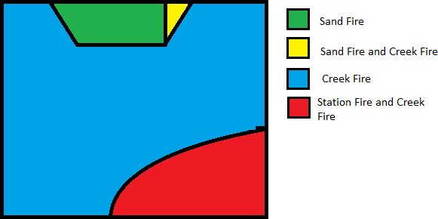
Figure 1. Schematic map of the fire history of the trail areas at the Gold Creek Preserve, Angeles National Forest. The Red Trail had recent fires with the highest intensity, the Green Trail was subject to medium intensity fires, and the Blue Trail had a recent low intensity fire.
Analysis: We will be working with soils data and DNA sequences. Students will be using the USDA Web Soil Survey to mine for soil physical and chemical properties Metadata. The Metadata is data about the samples such as physical, chemical, categorical and geographical information about the soil samples from which the environmental DNA sequences have been derived. Then, we will combine metadata with the sequencing data.
Instructional Videos Available: Soil trophic cascades following wildfire video, Soil Sampling Day 3: Gold Creek video, Soil Survey Summary Tutorial video
Materials: Web Soil Survey Tutorial pdf , Web soil survey AOI Import File , Gold Creek OTU Table and Metadata , PUMA Manual Ranacapa tutorial pdf
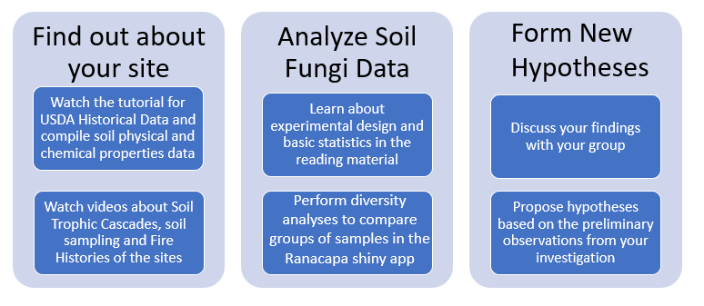
Figure 2. Flow chart for the soil fungi after fire lab activity.

Part I: Soil Physical and Chemical Properties
First, watch the Soil trophic cascades following wildfire lecture. Then, watch the Soil Sampling Day 3: Gold Creek video to learn more about the sampling sites.
Now you are ready to begin the Soil survey summary tutorial in order to collect metadata for your case study. Review the Soil Survey Tutorial Pdf and watch the Soil Survey Summary Tutorial. Use the AOI Import File to define your area of interest.
You can also visualize all of the samples on the Sampling Map
Student Outputs:
Soil Map, Excel spreadsheet, and 1-paragraph summary of your Area of Interest from the Web Soil Survey Tutorial.
Part II: Fungal ITS Diversity
We will be performing a tutorial with the Ranacapa shiny app to build some initial hypotheses. You will load the Gold Creek Metadata file and OTU table into Ranacapa. Use the Ranacapa Tutorial PDF to begin to explore the diversity metrics for the Gold Creek data.
Please be patient with Ranacapa since the amount of time it takes to load is based on the current server traffic. It might take up to 5 minutes to load. The OTU table contains a large amount of information. Sometimes it will report an error in red but if you wait a few minutes, it will perform as expected and display the appropriate graph.
The tool you will be using to evaluate the differences in biodiversity in the fungal sequences is Ranacapa. First, you will evaluate the alpha diversity which is the within sample diversity, or the number of species identified in that sample. You will be using a statistical test called PERMANOVA, which is a variation of Fisher’s test, to test Beta diversity between samples. If a significant result is found, then you should carry on with the pairwise comparisons and use Tukey’s test.
Ranacapa Instructions and Student Outputs
Load your metadata and fungi OTU table into ranacapa by selecting the Data Import Tab and clicking on Custom import. (A common error is to load the files in a reversed order. Be sure to load the metadata and OTU tables into the correct fields.)
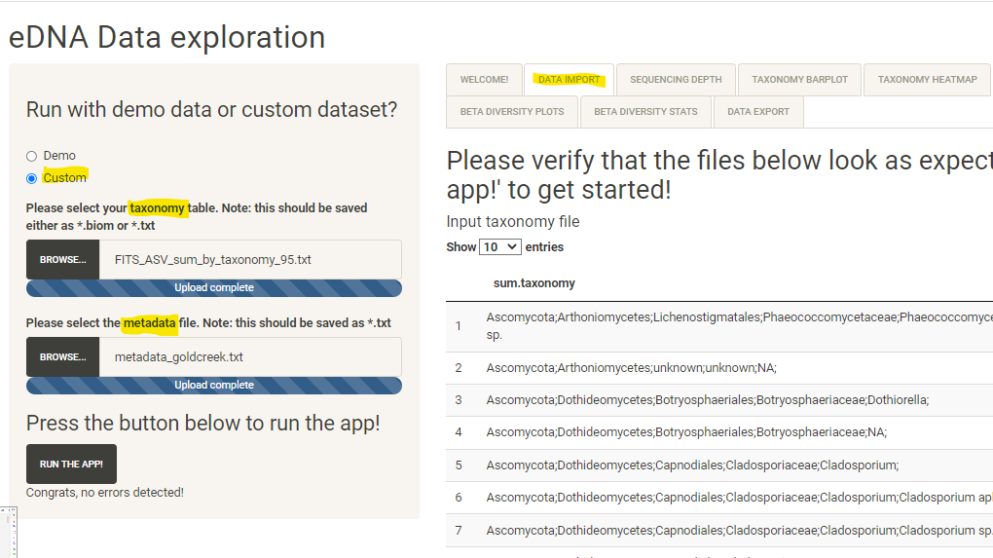
- Alpha Diversity refers to the total observed number of species for a sample category. In this case, we are interested in testing the hypothesis that the Blue Trail has the most observed fungi species compared to any other trail. View the alpha diversity plot for the “Trail” variable which you must select from the upper left-hand drop-down menu. (A common error is to leave the variable unselected, which will not result in a boxplot display.) Include a screenshot of your boxplot and a short statement about the results of your hypothesis in light of the alpha diversity statistics for the Trail variable.
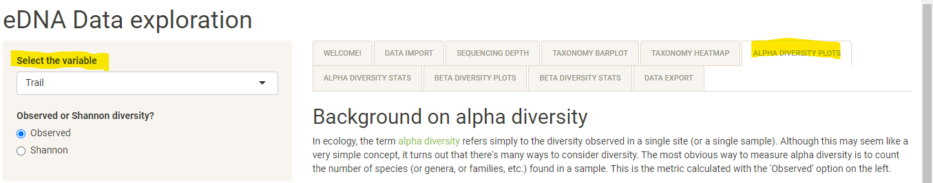
- Is the difference in the abundance of fungi between the trails primarily due to the phylum Basidiomycota or Ascomycota? Use the Taxonomy Barplot. You will need to select phylum as the taxonomic level on the left-hand menu to view the relevant results. What kind of evidence did you find to support your answer to this question? Include a screenshot and a 1-sentence caption for your answer to this question.
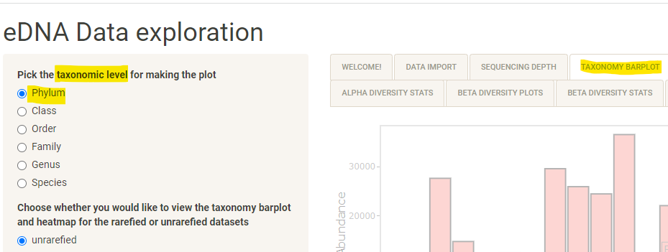
- What is the most abundant phylum of fungi in this dataset? Use the Taxonomy Heatmap. You will need to select phylum as the taxonomic level on the left-hand menu to view the relevant results. View the legend by scrolling to the far right of the window. Which samples have the highest counts for the most abundant phylum? The sample metadata file will help you to identify the samples with higher counts according to their sample numbers. Download your plot as a .png and include your image with your answer.
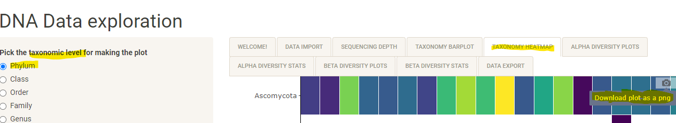
- Beta Diversity is a measure of the differences in species composition between a set of samples. It can reveal which samples are the most similar or different from one another, taking into account species that both samples or categories have in common. Use your observations of the Beta Diversity Plots to answer the following questions: Does it appear that most samples are similar overall? Do the oak and charred oak samples appear to be highly similar overall in terms of their species composition for fungi? The oak samples can be isolated by clicking on their legend labels on the right-hand side of the PrinCoA plot.
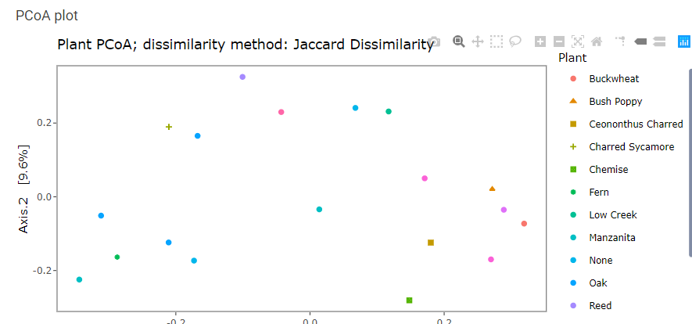
- Use the Beta Diversity Statistics to test the hypothesis that the Blue Trail species composition is similar to the Green Trail species composition. Include a screenshot with your answer. Are there any further hypotheses you would like test based on these preliminary results? Suggest at least two additional questions that could be answered with this data.
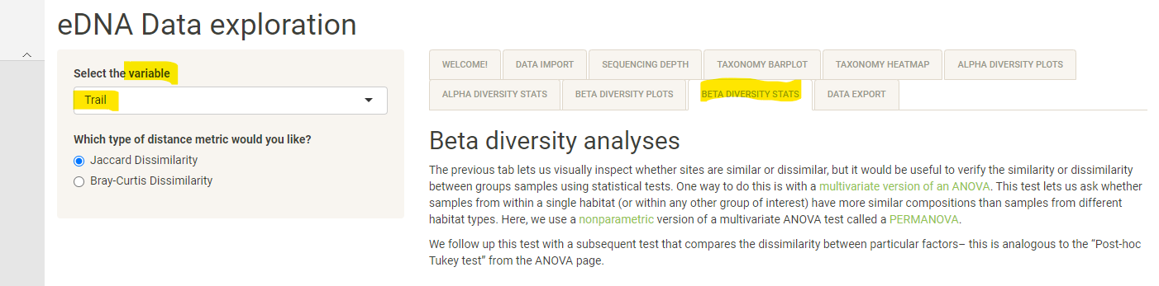
Follow-up Questions
- If the fungal composition of a plot differs, can we be sure that the difference is due to fire severity? What are some additional factors that differed between the sites, based on your investigation of the soil physical and chemical properties using the USDA Web Soil Survey?
- What would be the advantage(s) of having fungal data not only from after the fires but also from before the fires?
- What might be some advantage(s) of having a larger number of distinct plots with known fire histories?

References
National Research Council. Susan R. Singer, contrib. 2012. Discipline-Based Education Research: Understanding and Improving Learning in Undergraduate Science and Engineering. Washington, DC: The National Academies Press. https://doi.org/10.17226/13362
Banta et al. 2017. Integrating Genomics Research throughout the Undergraduate Curriculum: A Collection of Inquiry-Based Genomics Lab Modules. CBE Life Sciences Education, Vol. 11, N0. 3. https://doi.org/10.1187/cbe.11-12-0105
Toven-Lindsey, Brit et al. “Increasing persistence in undergraduate science majors: a model for institutional support of underrepresented students.” CBE life sciences education vol. 14,2 (2015): ar12. doi:10.1187/cbe.14-05-0082
Senn, S.; Bhattacharyya, S.; Presley, G.; Taylor, A.E.; Nash, B.; Enke, R.A.; Barnard-Kubow, K.B.; Ford, J.; Jasinski, B.; Badalova, Y. The Functional Biogeography of eDNA Metacommunities in the Post-Fire Landscape of the Angeles National Forest. Microorganisms 2022, 10, 1218. https://doi.org/10.3390/microorganisms10061218
Calflora. Thickleaf Yerba Santa. Eriodictyon crassifolium. Retrieved March 28, 2022, from https://www.calflora.org/app/taxon?crn=3184
United States Forest Service. The Recovery of Soil Fungi Following a Fire. Science Findings June 2018. https://www.fs.fed.us/pnw/sciencef/scifi207.pdf
US Forest Service. Species Eriodictyon crassifolium benth. Retrieved March 28, 2022, from https://www.fs.fed.us/psw/publications/beyers/psw_2018_beyers005_montalvo_eriodictyon-crassifolium.pdf
Laskin, Alexander et al. “Molecular characterization of nitrogen-containing organic compounds in biomass burning aerosols using high-resolution mass spectrometry.” Environmental science & technology vol. 43,10 (2009): 3764-71. doi:10.1021/es803456n
Demain, A., Martens, E. Production of valuable compounds by molds and yeasts. J Antibiot 70, 347–360 (2017). https://doi.org/10.1038/ja.2016.121
Scott Werts. (2021, May 4). Exploring cation exchange capacity through the use of the soil survey. Teaching Hydrogeology, Soils, and Low-T Geochemistry in the 21st Century. On the Cutting Edge Exemplary Teaching Activities collection. Retrieved March 28, 2022, from https://serc.carleton.edu/NAGTWorkshops/hydrogeo/HSG2013/activities/71584.html
Kandlikar GS, Gold ZJ, Cowen MC, Meyer RS, Freise AC, Kraft NJB, Moberg-Parker J, Sprague J, Kushner DJ, Curd EE. ranacapa: An R package and Shiny web app to explore environmental DNA data with exploratory statistics and interactive visualizations. F1000Res. 2018 Nov 1;7:1734. doi: 10.12688/f1000research.16680.1. PMID: 30613396; PMCID: PMC6305237.

