Title:
Weathering the Heat: Ecology and Earth’s Climate System

Author(s):
Anne Fernald Cross, PhD
Tulsa Community College
anne.cross@tulsacc.edu

Abstract:
This module presents a science-based story to demonstrate how climate determines the global, long-term, large-scale distribution of living organisms; whereas, weather determines the local, short-term, small-scale ecology of living organisms. Life thrives within specific, often narrow ranges of temperature and precipitation – two main players in climate and weather. Using a systems-based approach, the module first reviews background information on climate, weather, components of the Earth’s climate system—atmosphere, biosphere, cryosphere, hydrosphere, and geosphere, the greenhouse effect, and greenhouse gases (GHG). Second, the module introduces connections between humanity’s GHG emissions, radiative forcing and current- and projected temperatures on Earth. Third, the module presents the many ways in which climate change affects insects globally. Lastly, the module focuses on scientific communication with a short New York Times article and a peer-reviewed paper, considering whether humanity can be hopeful in the face of climate change. The module may be presented to students in one of three learning formats—instructor-led, student-led or student online. This module considers not only what students should know, but also how they know it and how they can use that knowledge. The module also focuses on timely and current information that is in the news – climate change. It is the first of three modules linking global climate, ecological tolerance and mosquito range expansion, and human health.

Topic: A systems-science approach to science behind global warming with an example from insect ecology

Focus: Earth is a system of integrated components—atmosphere, biosphere, cryosphere, geosphere, hydrosphere—students will recognize that when one sphere changes due to natural or anthropogenic causes, the other four spheres change concomitantly. Living organisms depend on and respond to the climate system, especially ectotherms, such as mosquitoes. The systems-based story is presented in a step-by-step manner.
Grade level: 9th-12th; undergraduate majors- and non-majors biology
Learning outcomes:
- Distinguish climate from weather
- Identify five components of the Earth system and explain the role of each in global energy transfer
- Review the Greenhouse Effect
- Discover how forcings, feedbacks, and tipping points influence Earth's climate system
- Explore the components of radiative forcing
- Identify the main greenhouse gases (GHG)—CO₂, methane (CH₄), water vapor (H₂O), nitrous oxides (NO_{x}), fluorinated-gases (F-gas)
- Examine NASA data on global temperature and atmospheric carbon dioxide (CO₂) concentrations
- Explain how climate change influences species’ range shifts for vegetation and insects
- Review the information from the first 8 lessons by comparing various components of the natural and anthropogenic influences on climate system structure and function and complete the worksheet with others via – class discussion, discussion board posts, etc.
- Ponder whether humanity can remain hopeful in the face of climate change

Timeframe:
The learning module may be presented in three different formats and, consequentially the timeframe may vary. (Time estimate to complete the set of 10 lessons is 2 – 3 hours in two lecture periods or one lab period)
- An instructor-led learning format in which the instructor guides the learning process. The instructor provides instruction, direction and support to the learners. For example, in a traditional classroom setting, the instructor may lead students through each lesson and provide instantaneous feedback to learners as they work through the material together. This format effectively helps learners review- and acquire new knowledge and skills and may foster a sense of community among learners.

- A student-led or flipped learning format in which students actively learn together while the instructor facilitates the learning process. Students review the materials in the PowerPoint at their own pace before coming to class, then in class, lead one another through each lesson. This format helps learners take ownership of their learning, then through collaboration with others in class, deepen their knowledge. In this format, the instructor acts primarily as a facilitator and provides guidance as students lead one another through each lesson.

- A self-paced, online learning format through a Learning Management System (LMS) allows learners the flexibility to work at their own convenience, pace and on their own timeframe. Learners can also revisit and review materials before progressing to the next lesson. All learning materials and feedback are available through an online platform which learners can access from any location through an internet connection. Group activities may be facilitated by the instructor through an online discussion board.
Structure:
Ten lessons cover the topic of global climate and global warming in the context systems thinking, first introduced in the early 2000s by the late Donella Meadows. The lessons may be used individually or together depending on the goals of each instructor.
The PowerPoint: Weathering the Heat: Ecology and Earth’s Climate System, is the primary mode of presentation of this module for both instructors and students. There are two PowerPoint slide presentations. An instructor version with answers to the assessments, and a student version without answers to the assessments.
The first 8 lessons contain learning objectives, lesson content, and a lesson assessment. Lesson #9 reviews the first 8 lessons with a worksheet to be completed in various ways depending on the modality of presentation. The final lesson, Lesson #10 presents a hopeful view of climate change.
The module-outline below (lessons #1 through #10 inclusive) should be used by the instructor in conjunction with the Instructor-version of the PowerPoint Presentation. Instructions for what to be covered, the assessment key for each lesson, and sources for each slide may be located in “Notes section” on each slide.
Module Outline: Weathering the Heat: Ecology and Earth’s Climate System
Lessons #1 and #2 distinguish climate and weather, and introduce the five spheres of Earth’s climate system. (30 – 60 minutes, including discussion and writing exercise)
Lesson #3 reviews the Greenhouse Effect. (20-30 minutes with a drawing exercise)
Lessons #4 through #6 introduce the concept of an Earth System in balance with the main driver of global energy transfer, radiation. In turn, as greenhouse gases (GHG) impact the transfer, emission, and absorption of radiation, GHG alter forcings, feedbacks, and tipping points inherent to Earth’s climate system. (45-60 minutes depending on format)
Lesson #7 illustrates the consequences of human impacts on the global climate system by focusing on the 800,000-year ice core record of atmospheric carbon dioxide (CO₂) and Earth’s temperature over the same time period. (10 -20 minutes)
Lessons #8 introduces the concept of species range shift with climate change for vegetation and insects (10 -20 minutes)
Lesson #9 reviews the content and context of the first eight lessons (times will vary)
Lesson #10 explores the human notion of hope in the context of global climate change. (45-90 minutes, depending on whether the format includes class discussions)
NOTE: This is the first of a three-module set. This Learning Module sets the stage for relating Earth system science across the five spheres to natural and human processes on Earth. The next module explores the ecological concept of range of tolerance in living organisms to the marked range expansion of disease-carrying mosquitoes. And, the third module, focuses on the connection between global warming, mosquito range shifts, and the consequences for the health and well-being of another living organism, humans.
List of materials:
- Individual Student Materials
  - PowerPoint: Weathering the Heat: Ecology and Earth’s Climate System
  - Learning Module Lesson Review Sheet
- Lesson Materials included in each PowerPoint Presentation for 10 lessons

Equipment:
- video projection or online sharing capability
- Whiteboard, dry erase markers (in-person learning)
- Learning Management System (LMS)
- Personal computer with high-speed internet connection (online learning)
- Discussion board or Packback (online learning)

Procedure and general instructions (for instructor).
- Set-up Instructions:
  - Locate the PowerPoint Presentation
  - Copy the Lesson #8 Worksheet for in-person learning
  - Share the Blackboard link or other LMS for online learning
- Background
The two words “climate” and “change” are shortened to the sound bite climate change. Most students know from their day-to-day, local weather experiences that climate is changing; however, many find it challenging to relate their short-time, small-scale experiences to the longer-term, large-scale global processes. They also may conflate natural climate change with human-induced climate change. This module proceeds from the science of climate change to the human angst about climate change.

Description:
This Learning Module explores the topic of climate change in the context of systems thinking, which the late Donella Meadows first introduced in the early 2000s. By examining the Earth as a system of integrated components – atmosphere, biosphere, cryosphere, geosphere, hydrosphere – one recognizes that when one sphere changes due to natural or anthropogenic causes, the other four spheres change concomitantly. Please note that the descriptions below are written for an online presentation. To adapt each lesson, in turn, for instructor- or student-led presentations please refer to the notes section on each slide in the PowerPoint presentations.
- Educator Note
  - Students should have a general idea of earth system science from middle school or high school, including ideas around the inputs, outputs, fluxes and pools for energy, radiation, and water at the global scale.
  - The learning module includes a variety of student interaction techniques to support equitable participation for in-person and online learner.
  - Each lesson focuses on one concept and offers the background information needed for the subsequent lesson; therefore, the lessons should be used in the order presented.
  - Each lesson has a companion PowerPoint slide that may be used in conjunction with this document. For example, if this module is used in-person in the classroom, the educator should locate the Educator PowerPoint Presentation.

Background Information on Climate, Weather, the Greenhouse Effect, and Greenhouse Gases
Guiding Questions:
- What’s the difference between climate and weather?
- How does the systems-based approach show connections between Earth’s atmosphere, biosphere, cryosphere, hydrosphere and geosphere?
- How do humans influence Earth’s climate system?
- How do you think plant and animal species will respond to climate change?
Students learn to:
- Distinguish climate from weather
- Identify five components of the climate system and explain their role in global energy transfer
- Review the Greenhouse Effect: Human-enhanced
- Discover how forcings, feedbacks, and tipping points influence Earth's climate system
- Explore the components of radiative forcing
- Identify greenhouse gases (GHG)—CO₂, methane (CH₄), water vapor (H₂0) nitrous oxides (NO_{x}), fluorinated-gases (F-gas)
- Examine NASA data on global temperature and atmospheric carbon dioxide (CO₂) concentrations
- Recognize the connection between climate change, specifically global warming, and species’ range shifts
- Review, collate and discuss data (from the 7 previous lessons) on in a data table with a classmate or individual
- Ponder whether humanity can remain hopeful in the face of climate change
Instructions:
The learning module contains 10 lessons; one of which is a review. Learning objectives state the purpose of each lesson. Typically, a video link or a website link leads the learner through the primary content of the lesson. Following the presentation of content, the learner completes one of various activities – fill-in-the-blank, short essay, make a drawing, true/false, and multiple choice.
This module is not timed.
Learners may collaborate with one or two other classmates with on this assignment. Each learner is responsible for submitting their own work, as work completed with or copied from other learners earns no points.
Please find the Module presented in a sequence from Lesson #1 through Lesson #10 below. As previously mentioned the information below complements each lesson as presented in the Powerpoint presentation, Weathering the Heat: Earth’s Climate System and Insect Ecology.

Introductory Slides (PowerPoint slides #1 through #5)

Slide #1 Title

Slide #2 Background Information

Slide #3 Module Learning Objectives

Slide #4 Instructions for students/instructor

Slide #5 Overview of lesson contents

LESSON #1. Climate vs Weather PowerPoint Slides #6 through #9
Learning Objectives
- Differentiate between climate and weather
- Identify a Global Circulation Model (GCM) created by atmospheric scientists
- Recognize how human activity and human behavior limit the certainty of GCMs
Students: WATCH this video “Global Weirding” (2018) by atmospheric scientist and Chief Scientist at The Nature Conservancy, Katherine Hayhoe, PhD.
Watch Video 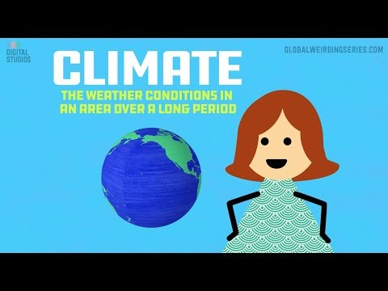
Climate vs Weather | Global Weirding
Duration: 8:04
User: n/a - Added: 10/3/18
Student ASSESSMENT_ Complete this paragraph using the word bank below.
The daily ___________ [A] includes fluctuations in temperature, relative humidity, and atmospheric pressure at a small-scale over a short-time scale of several days. It's average at the large-scale and over the longer-time scale of 20 to 30 years is called the _____________ [B]. To model climate and weather, atmospheric scientists derive GCMs, also called ______________ [C] using measurements of natural variability in the conservation of energy, the mass of water and the mass of air mass at the global scale. Scientists also include measurements of regional- and local _____________[D] in air temperature, pressure, density, water vapor content, and wind magnitude in GCMs. When creating and modifying GCMs to predict the future weather and future climate, atmospheric scientists, like Dr. Hayhoe must include uncertainties due to ________________[E]. These are:
- Human ________[F] – For example, how will planet Earth respond to humans continually pumping carbon dioxide and other greenhouse gases into the atmosphere?
- Human ________[G] – For example, which choices that humans make today will set the course of global climate in the future?
Word Bank:
activity
behavior
climate
general climate models
global circulation models
human activity and human behavior
variability
weather
weather models
LESSON #2. Earth’s Climate System. PowerPoint Slides #10 through #15
Learning Objectives
- Recognize the natural, global-scale phenomenon—Earth’s climate system
- Identify the components of Earth’s climate system—the atmosphere, the hydrosphere, the cryosphere, the lithosphere (geosphere), and the biosphere.
- Determine the interactions between the Earth System components
Students: Read the quote below.
“Once we see the relationship between structure and behavior, we can begin to understand how systems work, what makes them produce poor results, and how to shift them into better behavior patterns.”
— Donella Meadows (2008) Thinking in Systems: A Primer. Chelsea Green Publishing, White River, VT. 240 p.
Study the image below and locate the five components of Earth's climate system.
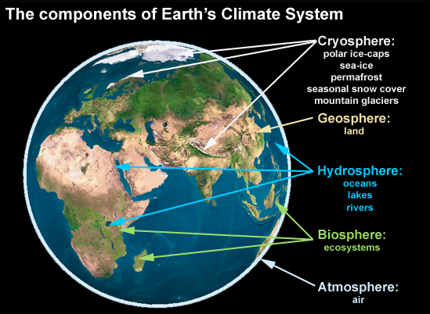
Source: https://skepticalscience.com/pics/climate-components.jpg
Students: Watch this video on the climate system. Observe how each component – cryosphere, geosphere, hydrosphere, biosphere, and atmosphere – contributes to the overall behavior of Earth’s climate.
Students: Click here for an explanation of the "Earth as a System."

Students: Review Table 1. Five Spheres of the Earth Climate System
- Review the definition for each sphere.
- Click on the NASA website to read about how each sphere interacts with the other four.

Atmosphere | A mix of gases – nitrogen (78%), oxygen (21%), trace gases (methane, water vapor, etc.) ice crystals, aerosols, dust particles – forming a layer approximately 480-km thick around the Earth. The two layers that most influence climate at the Earth's surface are the troposphere and stratosphere.  About the Atmosphere_NASA
Biosphere | The parts of Earth where life exists – extending from the deepest root systems of trees to the dark environment of ocean trenches, to lush rain forests and high mountaintops. All living things on land, air, and oceans make up this component.  About the Biosphere_NASA
Cryosphere | Any place on Earth where water is in its solid form, where low temperatures freeze water and turn it into ice; and occurs in many places around the Earth in addition to the Arctic and the Antarctic. The name of this component comes from the Greek word for cold, "kryos."  About the Cyrosphere_NASA
Geosphere | Also called the lithosphere, it includes the rocky outer shell and inner crust of Earth. Land Surface includes geophysical processes and parameters involving the Earth’s land surfaces (e.g., surface temperature, soil moisture, vegetation cover, and land use).  About the Geosphere_NASA
Hydrosphere | The liquid water on Earth – mostly in the oceans, lakes, and rivers. It also includes the geophysical parameters that characterize the oceans (e.g., temperature, salinity, sea surface topography, chemistry/biology optics) operating at depth and at its surface.  About the Hydrosphere_NASA

Student ASSESSMENT_ Short Essay/Class Discussion
CER Method for short answers and essays of at least 100 words.
- Claim – A statement that answers the question.
- Evidence – The scientific data and details that support your claim.
- Reasoning – Explains the “who, what, when, where, why and how” the evidence supports your claim.

Imagine: It is your job to detect subtle changes in Earth’s climate system.
Which component would you chose to monitor and why?

Review the example below and a note: Please allow at least 30 minutes to write, re-write, edit and proof-read your essay.
CLAIM: I would monitor the hydrosphere because some of the liquid water, from oceans, evaporates into the atmosphere as water vapor. And, it’s likely that an increase in atmospheric water vapor could add to the energy trapping effect of greenhouse gases. If this causes additional global warming, it would be an example of a positive feedback to climate change.

EVIDENCE: Liquid water stored in surface water on Earth include the oceans (96.5%), groundwater (1.7%), soil moisture (0.001%), and lakes, swamps, rivers (0.023%), and the remaining 1.776 % is frozen as snow, ice or permafrost (Gleick 1996). Water changes state between solid, liquid and gas as a consequence of temperature and energy transfers.

REASONING: I would monitor the hydrosphere. Even a miniscule change in the hydrosphere, or the global water cycle, ought to lead to a detectable change in Earth’s climate. The oceans store most of Earth’s water (96.5% or 1,338,000 x 10³ km³), and a small fraction (0.032%) or 436.5 x 10³ km³/year evaporates from the oceans into atmosphere (Oki and Kanae 2006). Energy transfers occur when water changes state between solid, liquid and/or gas. The energy of evaporation breaks bonds between individual water molecules as liquid water converts to water vapor. As the Earth’s temperature increases, more water evaporates into the atmosphere and is stored as water vapor (Buis 2022). However, this increase does not function as a driver of global warming. It amplifies warming caused by other greenhouse gases (GHG) which, in turn, induce a positive feedback to global warming (Buis 2022). Just like when I take a shower, the bathroom warms up as the liquid water changes to- and is stored as steam. (163 words)

Literature Cited:

Buis, A. (2022). Steamy relationships: How atmospheric water vapor amplifies Earth’s Greenhouse Effect. Ask NASA Climate
Gleick, P.H. (1996) Water Resources. In: Schneider, S.H., Ed., Encyclopedia of Climate and Weather, Oxford University Press, New York, Vol. 2, 817-823.
Oki, T & S Kanae (2006) Global hydrological cycles and world water resources. Science 3133:1068-1072.
LESSON #3. The Greenhouse Effect. PowerPoint Slides #16 through #19
Learning Objectives
- Explain how the greenhouse effect works in terms of Earth’s climate
- Compare the Greenhouse Effect to an actual greenhouse
- Distinguish between incoming solar radiation and outgoing radiation from Earth’s surface
- Describe how carbon dioxide and methane trap outgoing radiation

Students:
Navigate to NASA_Causes of Climate Change
Click on the The Greenhouse Effect on the left side of the page
Watch the animation (~17 seconds) or this explanation What is the greenhouse effect? (2:29 minutes)
Scroll through the website NASA_Climate_Kids for more details on the greenhouse effect

Student ASSESSMENT_ Draw the greenhouse effect (see the examples below)
Label the following components:
- Earth’s surface
- Earth’s atmosphere
- The Sun
- Space
- Solar radiation (sunlight)
- Infrared radiation (heat)
- Reflected solar radiation
- Absorbed solar radiation
- emitted solar radiation
- short-wave radiation
- long-wave radiation
- reflected long-wave radiation
- absorbed long-wave radiation
- emitted long-wave radiation
- greenhouse gases

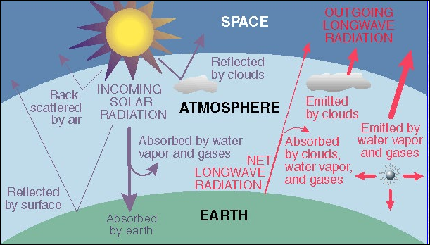 | 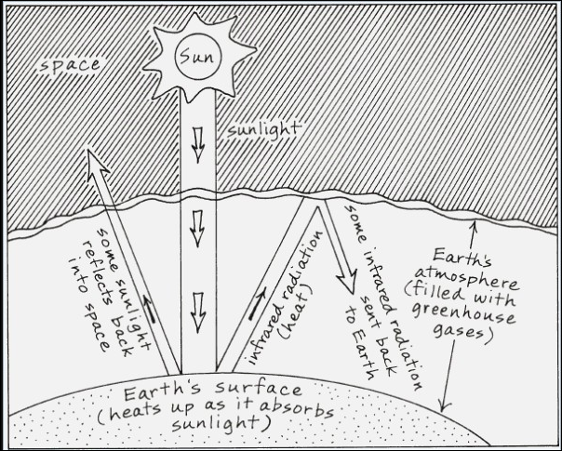

Students: Use the space below for your drawing.

LESSON #4. Forcings, Feedbacks and Tipping Points. PowerPoint Slides #20 through #22
Learning Objectives
- Define and recognize a climate forcing
- Define and recognize a climate feedback
- Define and recognize a climate tipping point
Earth's climate is a natural phenomenon and is studied by scientists from many disciplines. Three main drivers determine how the climate system behaves -- forcings, feedbacks, and tipping points.
Students: Navigate to the website https://climate.nasa.gov/nasa_science/science/.
Student ASSESSMENT_ Fill in the blank.
- The initial drivers of climate are called _____________and include solar irradiance, greenhouse gas emissions, and aerosols, such as ashes, smoke and soot. Scientists use them in GCMs to better predict the long-term climate regime on Earth.
- Climate ___________________ are processes that can either amplify or diminish the effects of solar irradiance, greenhouse gas emissions, and aerosols, such as ashes, smoke and soot.
- Events that increase an initial warming event are called "positive feedbacks." Events that reduce an initial warming event are called "negative feedbacks." The most powerful positive feedback is the ________________.
- An abrupt move away from the stable state of Earth's climate system is called a ______________ and includes, changes in stable ocean circulation, ice loss, and methane releases.
- The most powerful tipping point is thought to be ______________________because it contributes to the atmospheric load of greenhouse gases and it derives from burning vast swathes of peatland and melting of the permafrost in the northern latitudes.
Word bank:

CH₄ (methane) release into the atmosphere
Feedbacks
Forcings
Ice albedo, also known as ice reflectivity
Tipping points
LESSON #5. Radiative Forcing. PowerPoint Slides #23 through #27
Learning Objectives
- Explain radiative forcing
- Identify 8 components of radiative forcing
- Determine which component is the most powerful or the components that are the most significant

Students: Navigate to MIT Climate Explainers or MIT_Climate Science, Risk & Solutions Guide to examine one example of a climate forcing mechanism, called radiative forcing.
Students: Review the graphs: PennStateU_Climate_Education and Energy Education_Radiative Forcing
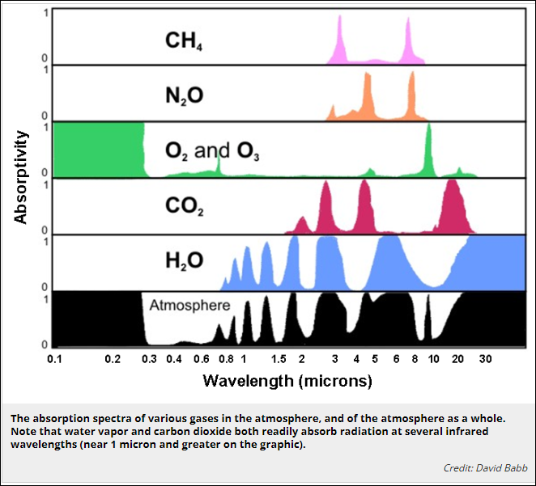 | 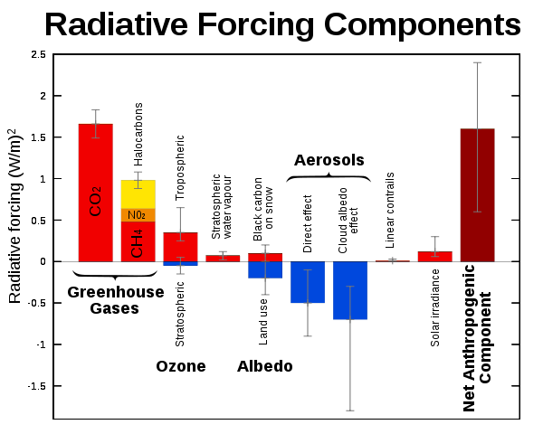
Student ASSESSMENT_ You explain the concept of radiative forcing to a friend.
- You tell them that radiative forcing is the difference between the amount of incoming solar radiation that strikes the Earth's surface and the amount of long wave radiation that is reflected back to space.
- You also tell your friend, that based on their ability to trap outgoing longwave radiation, carbon dioxide and other greenhouse gases (such as CH₄ (methane) function as a heavy winter blanket thereby keeping the Earth warm.
True or False: You simplify the concept of radiative forcing to the statement--"radiation in, radiation out" which is the same as "Power coming into Earth - Power leaving the Earth = Radiative Forcing Amount."
LESSON #6. Greenhouse Gases. PowerPoint Slides #28 through #38
Learning Objectives
- Identify the greenhouse gases (GHG)
- Describe the greenhouse warming potential (GWP) for each gas
- Explain the source of each greenhouse gas
- Determine which gases are from anthropogenic (human) sources and which gases are from natural sources
Students: Watch this video What are the main greenhouse gases?
Student ASSESSMENT_ 1A_Recall and list the big six greenhouse gases.
Water vapor (H₂O)
Carbon dioxide (CO₂)
Methane (CH₄)
Ozone (O₃)
Nitrous oxide (N₂O)
Chlorofluorocarbons (F-)
Student ASSESSMENT_ 1B_Review the graph below and have this exchange with your friends.
- You tell your friends that we (humanity) should ignore the low atmospheric concentrations of methane (CH₄) from fracking and oil drilling sites and cattle and other ruminant animals, nitrous oxide (N₂O) from fossil fuel combustion, lightning, agriculture, and microbial processes, and man-made fluorinated gases (F-gas).
- Your friends question your statement and ask why should we ignore the contribution of the greenhouse gases CH₄, N₂O and F-gases to global warming.
- You answer that because the percentages of methane (CH₄), nitrous oxide (N₂O) and fluorinated gases (F-gas) are so small that they have no effect on radiative forcing.
True or False: Your reasoning is correct because you know that CO₂ is the only greenhouse gas that affects radiative forcing.
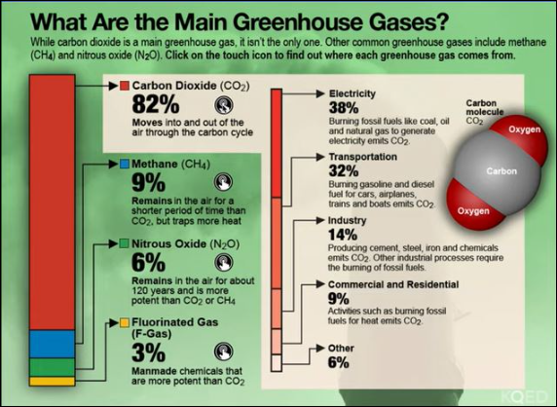
https://cdn.kqed.org/wp-content/uploads/sites/39/2014/11/MainGHG.jpg
For a more entertaining take on each of the greenhouse gases navigate to NASA_Meet the Greenhouse Gases!
LESSON #7. Earth’s Temperature. PowerPoint Slides #39 through #40
Learning Objectives
- Determine the trend in global temperature from 1990 to 2019
- Determine the trajectory for atmospheric carbon dioxide concentrations from 2002 to 2016
Student ASSESSMENT_ Navigate to the website NASA Climate Time Machine_2022
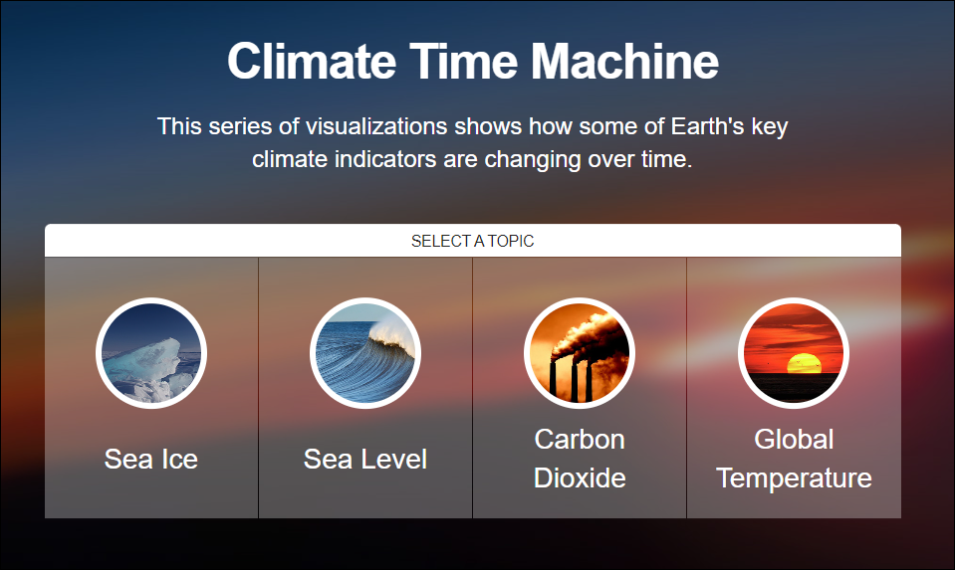
- Students: Click on the interactive link for global temperature. What is happened to global temperature from 1884 to 2021?
  - Increased
  - Decreased
  - Stayed the same
- Students: Click on the interactive link for carbon dioxide from 2002 to 2022. What happened to levels of carbon dioxide from 2002 to 2022?
  - Increased
  - Decreased
  - Stayed the same
- Students: Click on the interactive links for sea ice and for sea level. Are changes linked to temperature or CO₂?
  - Increased
  - Decreased
  - Stayed the same
Students: OPTIONAL REVIEW NASA website_Understanding our planet to benefit humankind

LESSON #8. Species Range Shifts – Vegetation and Insects. PowerPoint Slides #41 through #42

Learning Objectives
- Examine the connections between biotic and abiotic components of Earth System
- Describe a species range shift
- Provide one example from a plant or an insect of a species range shift

Student ASSESSMENT_Using Models
INSTRUCTOR NOTE: This format derives from the 2016 paper by Laverty et al. that provides guidelines for writing 3-D (Practices, Core Ideas and Crosscutting, interdisciplinary ways of thinking), questions that encourage critical thinking and analysis by students. Specifically this is a Constructed Response question that requires students to do just that, construct the response.
Laverty JT, Underwood SM, Matz RL ,Posey LA, Carmel JH, Caballero MD, et al. (2016). Characterizing College Science Assessments: The Three-Dimensional Learning Assessment Protocol. PLoS ONE 11(9): e0162333. doi:10.1371/journal.pone.0162333
Lesson #8 ASSESSMENT_Using Models. In science, models often represent a hypothesis about how a system works. Recall that Whittaker’s Biome Model represents the global distribution of terrestrial biomes relative to the Earth’s mean annual temperature (MAT) and mean annual precipitation (MAP) – two factors related closely to climate.
Write down your thoughts and answer the following questions in the space provided. Make sure that each answer is between 50 and 100 words.
1. Explain the ecological concept that Whittaker’s Biome Model represents in terms of:
a. the x-axis and the y-axis
b. the relationship between the x-axis and the y-axis
c. the general environmental features of biomes
2. Pick one biome, name the selected biome, and describe how MAT and MAP vary over the biome. You may want to figure out the range of temperature (maximum and minimum) and the range of precipitation (maximum and minimum) for the biome.
3. Using the biome you described in question #2, predict and describe what might change in this biome’s environmental features if the global temperature increased or decreased by 1.5⁰ Celsius (2.7⁰Fahrenheit)?
4. Identify how the changes might be an advantage or a disadvantage to a population of plants, animals, insects and/or humans in the biome. Discuss the specific evidence supports your claim that the change was an advantage or a disadvantage to one group of living organisms, insects for example.
5. Describe how you used Whittaker’s Biome Model to predict the effect of global temperature on the environmental features of the biome you described in question #3.
Students: OPTIONAL Journal article: Harvey, Jeffrey A., Kévin Tougeron, Rieta Gols, Robin Heinen, Mariana Abarca, Paul K. Abram, Yves Basset, et al. 2023. Scientists’ Warning on Climate Change and Insects. Ecological Monographs 93(1): e1553. https://doi.org/10.1002/ecm.1553
LESSON #9a. Review. PowerPoint Slide #43 and blank Handout for students
REVIEW Step 1. Individual Student Activity_Complete the table.
- Natural processes in an ideal world show no influence of human activity
- Anthropogenic activity alters natural processes in three ways – enhance (+), neutral (0), destabilize (-)
- Note features of the natural processes covered in each of the preceding lessons
- Note anthropogenic activity for each natural process with a check (ü ) for yes and a dash (-) for no.
The first row (Lesson #1 climate) shows expectations for a thorough, complete answer.

Lesson | human  impact | Process | Natural Process  (define the term) | Anthropogenic Activity  (provide an example & its consequence)
1 | ü | climate | long-term weather  large-scale weather | release of greenhouse gases -- CH₄ & CO₂  increases thickness of stratospheric layer
 |  | weather
2 |  | climate system
 |  | - atmosphere
 |  | - biosphere
 |  | - cryosphere
 |  | - geosphere
 |  | - hydrosphere
3 |  | greenhouse effect
 |  | - infrared radiation
 |  | - solar radiation
 |  | - reflected radiation
 |  | - absorbed radiation
4 |  | climate system
 |  | - feedbacks
 |  | - forcings
 |  | - tipping points
5 |  | radiative forcing
 |  | - greenhouse gases
 |  | - ozone (O₃)
 |  | - water vapor (H₂O)
 |  | - albedo
 |  | - aerosols
 |  | - anthropogenic
 |  | - solar irradiance
6 |  | greenhouse gases
 |  | - carbon dioxide (CO₂)
 |  | - methane (CH₄)
 |  | - nitrous oxide (N₂O)
 |  | - water vapor (H₂O)
 |  | - fluorinated gas (F-gas)
7 |  | global temperature
 |  | atmospheric CO₂
8 |  | insect ecology
 |  | - species distribution
 |  | - phenology
 |  | - species interactions

LESSON #9b. PowerPoint Slide #44 and completed Handout for students
REVIEW Step 2. Group Student Activity_Review the table.
- Review the table completed for LESSON #9
- Determine whether human activity affects each natural process (total the check marks)
- Determine which natural processes are free from human activity (total the dashes)
- Select the one natural process that appears to be most affected by anthropogenic activity
- Select the one natural process that appears to be the least affected by anthropogenic activity

Students: Watch this oldie, but a goodie 2014_United Nations Climate Change video

Students: Pick one United Nations Climate Fast Facts

Students: Discuss your completed table, the video and one UN Climate Fast Fact

Student ASSESSMENT_ Summarize findings in three evidence-based statements:

1.
2.
3.

LESSON #10. Hope During Climate Change. PowerPoint Slide #45
Learning Objective
- humanity needs hope
Students: Read these two current articles New York Times article. and Columbia University News article
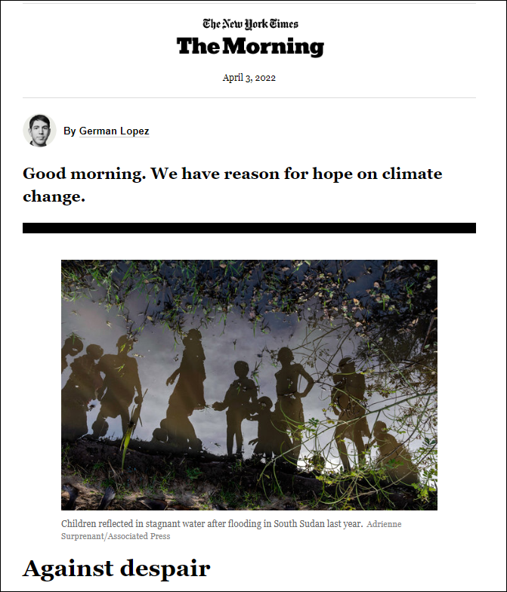

Students: THINK about this!
Do you agree with the author's claim -- Humanity can remain hopeful in the face of climate change?

Students: Skim the peer-reviewed article
Frumkin, H. (2022) Hope, health, and the climate crisis. The Journal of Climate Change and Health. 5:100115

Student ASSESSMENT_ Short Essay/Class Discussion:
Compose a short essay addressing the question – Can humanity be hopeful in the face of climate change?
- Refer to the New York Times article, “Against Despair.”
- Refer and cite to two peer-reviewed articles.
- Use appropriate scientific terminology and grammatically-correct sentences.

CER Method for short answers and essays of at least 100-250 words.
- Claim – A statement that answers the question.
- Evidence – The scientific data and details that support your claim.
- Reasoning – Explains the “who, what, when, where, why and how” the evidence supports your claim.

Procedure and general instructions (for students). Please refer to Lesson #2 for CER Example.
Blank Handout to REVIEW (for Lesson #9a and #9b)
ACTIVITY: Complete the table. (The first row from Lesson #1 has been provided as an example.)

Lesson | human  impact | Process | Natural  (no human influences) | Anthropogenic  (changes due to added human influences)
1 | ü | climate | long-term weather  phenomena | increase greenhouse gases;  alter stratospheric GHG;
 |  | weather
2 |  | climate system
 |  | - atmosphere
 |  | - biosphere
 |  | - cryosphere
 |  | - geosphere
 |  | - hydrosphere
3 |  | greenhouse effect
 |  | - infrared radiation
 |  | - solar radiation
 |  | - reflected radiation
 |  | - absorbed radiation
4 |  | climate system
 |  | - feedbacks
 |  | - forcings
 |  | - tipping points
5 |  | radiative forcing
 |  | - greenhouse gases
 |  | - ozone (O₃)
 |  | - water vapor (H₂O)
 |  | - albedo
 |  | - aerosols
 |  | - linear contrails
 |  | - solar irradiance
 |  | - anthropogenic component
6 |  | greenhouse gases
 |  | - carbon dioxide (CO₂)
 |  | - methane (CH₄)
 |  | - nitrous oxide (N₂O)
 |  | - water vapor (H₂O)
 |  | - fluorinated gas (F-gas)
7 |  | global temperature
 |  | atmospheric CO₂
8 |  | insect ecology
Notes:
Additional Resources on UDL and 4DEE
Universal Design for Learning
  - UDL definition reference
  - https://udlguidelines.cast.org/binaries/content/assets/udlguidelines/udlg-v2-2/udlg_graphicorganizer_v2-2_numbers-no.pdf

The attendant purposes of the module are to incorporate guidelines for Universal Learning Design (UDL) and ESA’s Four-Dimensional Ecology Education (4DEE).

Universal design for learning (UDL) CAST_UDL website
UDL is a teaching approach that works to accommodate the needs and abilities of all learners and eliminates unnecessary hurdles in the learning process. This means developing a flexible learning environment in which information is presented in multiple ways, students engage in learning in a variety of ways, and students are provided options when demonstrating their learning. UDL definition reference

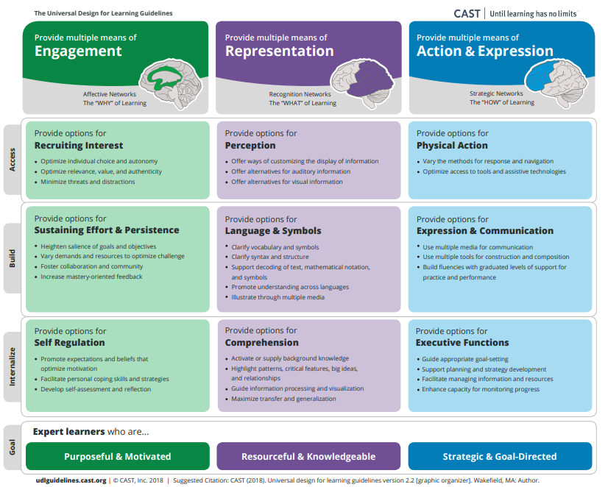

4DEE Four-Dimensional Ecology Education https://www.esa.org/4dee/
ESA’s 4DEE Framework is a dynamic set of ideas that must be revisited and revised periodically. It is not a mandate, but rather provides a set of recommendations for ecology curricula. The framework can be used both as a benchmark for instructors currently teaching undergraduate General Ecology and as a guide for instructors developing new courses. We look forward to learning with the community of ecology educators about how the framework is useful and brought to life through a diversity of approaches to teaching and learning.
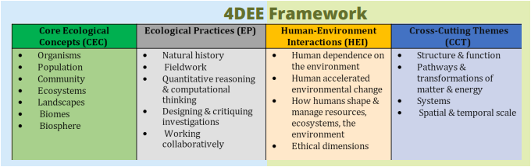

Core Ecological Concepts
Description: CEC follows the widely recognized hierarchy of ecology presented in most ecology textbooks, including individuals, populations, communities, ecosystems, landscapes, biomes and biosphere.

Ecology Practices
Description: EP includes approaches and methods used in doing ecology, e.g. natural history, fieldwork, quantitative reasoning, computational thinking, designing and critiquing investigations, and collaboration.
Human-Environment Interactions
Description: HEI includes dependence on the environment, human-accelerated environmental change, how humans can use ecological systems to shape and manage resources/ecosystems/the environment, ethical dimensions and communicating and applying ecology.
Cross-Cutting Themes
Description: CCT includes structure & function, pathways & transformations of matter and energy, systems, and spatial & temporal scales and processes (including evolution).

