EXPERIMENTS

Processes that Regulate Patterns of Species and Genetic Diversity

Anna M. McKee^{1,2,3}, Gary T. Green¹, John C. Maerz¹

¹Warnell School of Forestry and Natural Resources, The University of Georgia
Athens, GA 30602

²Current address: U.S. Geological Survey South Atlantic Water Science Center, Norcross, GA 30093

³Corresponding author: Anna M. McKee (amckee@usgs.gov)

ABSTRACT
During a single lab period, students simulate colonization and drift in artificial communities to understand how these processes affect distributions of biodiversity in small versus large communities with varying degrees of isolation. Plastic bins represent islands, and are situated to represent different degrees of isolation. Ziploc bags of candy represent individuals in the communities and different candies inside the bags represent the genetic composition of the individuals. Students simulate colonization and drift in communities by tossing, replicating, and removing individuals from their communities. Students record which individuals and candies are removed from and added to their communities over time, graph their data, and discuss results.

KEYWORD DESCRIPTORS
- Ecological Topic Keywords: Biodiversity, Colonization, Ecological drift, Evolution, Extinction, Genetic diversity, Genetic drift, Island biogeography, Species diversity

- Science Methodological Skills Keywords: Hypothesis generation and testing, theoretical thinking, random sampling, graphing data (extension activity for advanced students), use of graphing program (extension activity for advanced students)

- Pedagogical Methods Keywords: Games to teach ecology, participation, brainstorming (extension activity), think-pair-share (extension activity )

CLASS TIME
The activity alone may be completed during a two-hour lab session. However, additional time may be necessary for the introduction of theoretical concepts, which may be done during lecture and/or lab, and for the concluding discussion. If students calculate species richness and allelic richness on their own in class, additional time should be allowed.

OUTSIDE OF CLASS TIME
Students will need an additional 30 to 90 minutes to complete the discussion questions. Extension activities will require an extra 30 minutes to three hours depending on which activities are performed.

STUDENT PRODUCTS
Students will answer questions from their handout. An optional activity is for students to perform a small literature review (see Comments by Contributing Authors to Faculty Users of the Experiment) on the effect of neutral factors (i.e., area and isolation) and non-neutral factors (e.g., habitat features) on species and allelic richness and summarize the results from these studies.

SETTING
This lab may either be performed inside or outside.

COURSE CONTEXT
This activity was developed for an undergraduate upper level course for natural resources majors. Classes of 20 – 30 students work best for the activity. However it may be conducted with as few as ten students or as many as 40 students. For larger classes, two sets of islands could be created, or additional islands could be added to the layout.

INSTITUTION
The University of Georgia is a land-grant and sea-grant institution that offers baccalaureate, professional, master’s, and doctoral and degrees

TRANSFERABILITY
This activity requires no special equipment or settings; therefore it could be used at any other institution. A basic background in evolution and ecology is helpful for students to obtain the most out of this activity. However, if this material has been covered previously in the semester, this activity could be appropriate for non-majors as well.
ACKNOWLEDGEMENTS
This activity was created at the University of Georgia for the course FANR3200 Ecology of Natural Resources taught by Drs. Jay Shelton, Daniel Markewitz, and Kamal Gandhi. Without the willingness of these professors to try a new lab and allow multiple semesters for improvement, this activity would not have been created. We thank the students of FANR3200 Fall 2010, Spring 2011, and Fall 2011 as well as WILD4550/6550 Spring 2011 for their participation with the formative evaluation of this activity and their suggestions for improvement. We also thank the members of Dr. John Maerz’s lab in 2010 and 2011 for their helpful feedback on the activity. Lincoln Larson provided valuable assistance with the statistical methods for validating the effectiveness of the activity. Two anonymous reviewers provided invaluable feedback on the manuscript.

SYNOPSIS OF THE EXPERIMENT

Principal Ecological Question Addressed
How do the neutral ecological and evolutionary processes of drift and colonization affect biodiversity?

What Happens
- Allele → Candy
- Individual → Ziploc bag with candy
- Island → Plastic bin
- Community → Group of Ziploc bags in a plastic bin

Students simulate colonization and drift in animal communities. For each of ten rounds, students simulate a colonization attempt by randomly selecting one individual from their community and tossing it to another community. Successful colonization occurs when the individual lands inside the island of another community. Students then simulate reproduction by adding a duplicate of one of their individuals to their community and, if necessary, simulate mortality by removing the number of individuals necessary to bring the community size down to carrying capacity. Drift is represented by the combination of reproduction and mortality of randomly selected individuals. Students record all individuals and alleles leaving and entering the community.

Experiment Objectives
After completing this activity, students should be able to:
- Predict how the processes of colonization and ecological/genetic drift are likely to affect species and genetic diversity on islands and/or habitat patches
- List alternative systems to which the concepts of island biogeography may be applied
- Select from several optional habitat reserve designs with various combinations of habitat patch sizes and degrees of isolation which design(s) is (are) apt to maximize biodiversity
- List the main forces that influence distributions of biodiversity
Equipment/ Logistics Required
Supplies:
- 5 large bins (46cm x 66cm x 15cm or something similar in dimensions)
- 5 small bins (30cm x 46cm x 15cm or something similar in dimensions)
- 250 (+ 1 extra for each student in the class) zip-closure sandwich bags – 20 per large bin, 10 per small bin
- 15 copies of the animal pictures sheet, Appendix 1
- ~1200 (+4 extra per student in the class) assorted candies or marbles of different types/colors (we use Starbursts® and Jolly Ranchers®) – 4 per bag
- Packaging tape
- 10 copies of the species richness data sheet (1 per group plus extras for reproduction step), 30 copies of the allelic richness data sheet (3 per group), 1 copy of each island characteristic sheet, Appendix 2
- Computer with Excel
- 1 handout (see Detailed Description of the Experiment) copy per student in the class

Pre-lab Preparation (This should be done in advance):
- Follow the layout of bins as shown in Figure 1 (see below) to set up the islands.
- Cut out the animal pictures and tape each to a plastic bag.
- Place four candies and/or marbles (we use two Starbursts® and two Jolly Ranchers®) into 150 (plus the number of students in your class) bags
- Randomly select 20 bags to place in each large bin, and 10 bags to place in each small bin.
- Place 1 copy of the datasheet packet into each bin - make sure these datasheets have the island number and characteristics written in.
- Sort the bags by species and the candies/marbles by type and color so that students can easily duplicate their reproducing individuals.
Summary of What is Due
Students submit responses to discussion questions that compare class results to student hypotheses, gauge student understanding of the application of the material to alternative systems and conservation management, as well as when the material may not be applicable to conservation management.

DETAILED DESCRIPTION OF THE EXPERIMENT

Introduction
Processes that regulate biodiversity are central foci of ecology and evolutionary biology, and the conservation of biodiversity is something most people recognize as a contemporary issue and major management priority. This activity will focus on two of the three components of biodiversity – species and genetic diversity. Because the processes that regulate species and genetic diversity include biogeographic neutral forces related to space and scale (patch size and isolation), management for species and genetic diversity requires understanding how patch size and the relative isolation or connectivity of patches affects these scales of diversity within communities and populations.

Ecological communities gain species through speciation and colonization. Relative to colonization, speciation is rare and generally contributes little to community diversity over an ecological timeframe. The process of colonization is referred to as a neutral process, because it occurs independently among species regardless of their ecological differences. In contrast to the positive effects of colonization on species diversity, ecological drift causes the loss of species diversity. Ecological drift due to random fluctuations in population sizes, environmental stochasticity, and mortality (as opposed to species and population interactions) is also considered a neutral process because it occurs independent of ecological differences among species.

Island biogeography is one of the more prominent ecological theories that explains patterns of community diversity, and more recently to design and manage habitats and reserves for conservation (Sax et al. 2011). This theory, which was developed by E.O. Wilson and Robert MacArthur in the 1960’s (MacArthur et al. 1967), is based on the idea that colonization and extinction serve as balancing forces on species diversity within a community. Larger islands are expected to have more species and more individuals within those species (i.e., larger populations) than smaller islands because larger islands are likely to have a greater variety of habitat types to exploit and more resources for more individuals within those populations. Larger populations of any given species reduce the risk of extinction of that species due to random chance. Islands that are located closer to a source of immigrants (a mainland or other islands) are expected to have higher species richness because immigrants are likely to be more successful dispersing over a short distance versus a long distance, and higher recolonization rates, which reduces the chance of extirpation. Eventually, it is expected that an equilibrium level of species richness is reached through the balancing effects of ecological drift and colonization.

A similar neutral theory has been developed for population genetics (Kimura 1968). Instead of drift and colonization affecting species diversity, genetic drift (i.e., random loss of alleles in a population due to random differences in reproductive success and age at mortality among individuals) and colonization (commonly referred to as “gene flow” when referencing the movement of alleles) affect genetic diversity (Vellend 2004; Hu et al. 2006). Similar to the theory of island biogeography, an equilibrium value of allelic richness is reached through a balance between the additive processes of mutations and colonization and the subtractive processes of genetic drift and dispersal. Larger populations often have higher allelic richness than small populations because they are less likely to lose alleles from the population due to random chance. Populations located closer to a source of potential colonizers (the mainland or other islands) are expected to have higher allelic richness because colonizers are more likely to be successful dispersing over a short distance versus a long distance. On islands where colonization events are very infrequent, drift will lead to declines in species and allelic richness faster than colonization events can maintain levels of diversity. Species that generally occur as isolated populations but rely on occasional dispersal events for population persistence (e.g., pond-breeding amphibians) are often said to occur as metapopulations.

The parallel effects of drift (ecological and genetic) and colonization on species and genetic diversity, suggest genetic and species diversity should be correlated if drift and colonization are the primary processes regulating distributions of biodiversity. This is important for conservation because in situations where this is the case, similar management strategies could be used to optimize biodiversity at the species and genetic scales.

Based on this information, develop hypotheses regarding how species and allelic richness will change over time on islands of differing sizes with differing degrees of isolation.

Small Versus Large Islands
Starting with two islands, a small and a large island, both at carrying capacity with the maximum number of species/individuals possible in the community/population:

Species Richness | Allelic Richness
- Predict how species richness will change over time on small versus large islands.  - Describe verbally and graphically. | - Predict how allelic richness will change over time on small versus large islands.  - Describe verbally and graphically.
Written hypothesis: | Written hypothesis:
Graphical Hypothesis:  Label both curves on the graph. | Graphical Hypothesis:  Label both curves on the graph.
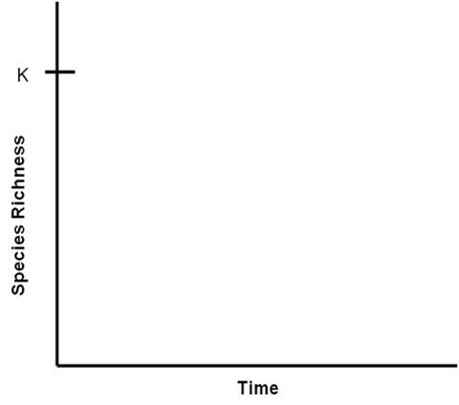  Species richness by time graph | 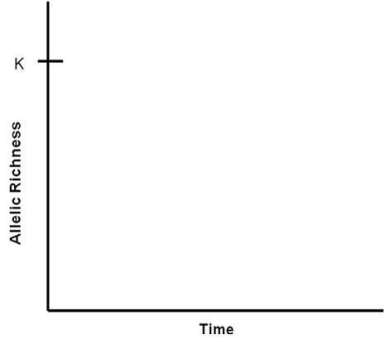  Allelic richness by time graph

Isolated Versus Well-Connected Islands
Starting with two islands of the same size, one in close proximity to another inhabited island and one very far from any other inhabited islands, both at carrying capacity with the maximum number of species/individuals possible in the community/population:

Species Richness | Allelic Richness
- Predict how species richness will change over time on the isolated versus well-connected island.  - Describe verbally and graphically. | - Predict how allelic richness will change over time on the isolated versus well-connected island.  - Describe verbally and graphically.
Written hypothesis: | Written hypothesis:
Graphical Hypothesis:  Label both curves on the graph. | Graphical Hypothesis:  Label both curves on the graph.
Species richness by time graph | Allelic richness by time graph

Important terms:
Allele – A unique variant of a DNA sequence at a gene
Allelic richness – The number of alleles (genetic variants) in a population
Average allelic richness – The average number of alleles per species in a community
Community – The composition of species within the same geographic location
Colonization - The introduction of a new species or allele into a community or population via dispersal from another community or population.
Connectivity – The relative proximity of an island to sources of immigrants. The opposite of isolation (greater isolation = lower connectivity)
Dispersal –The movement of an individual from one community/population to another community/population.
Drift –In this activity, ‘drift’ refers to the dual process of losing a random individual from a community, as well as losing that individual’s alleles
Ecological drift – The stochastic (random) extinction of species from a community
Gene – The DNA sequence that codes for a protein
Genetic drift – The stochastic loss of alleles (genetic variants) from a population
Island biogeography–A theory that describes the processes responsible for distributions of species richness across islands. This theory has since been applied to habitat islands, such as mountaintops, isolated wetlands, heads of coral, etc.
Metapopulation – Populations of the same species that are relatively isolated from each other and behave independently of each other but rely on occasional dispersal among them to prevent local extinction or to recolonize after local extinction has occurred, thereby reducing the risk of extirpation.
Neutral process–An ecological or evolutionary process that theoretically has the same directional effect on all species regardless of their ecological differences
Population - An interbreeding group of the same species, within the same geographic location
Species richness – The number of species in a community

Materials and Methods
Study Site(s): This lab may be conducted inside or outside. However, sufficient room for separating bins is necessary (~40 – 90 m²) as well as room for students to stand out of the way of tossed bags.

Overview of Data Collection and Analysis Methods: You will be assigned to an island community represented by a tub (the island; see Figure 1 for island layout) and bags of candy (individuals in the community). The islands have two distinguishing characteristics, their size and degree of connectivity/isolation (Figure 1).

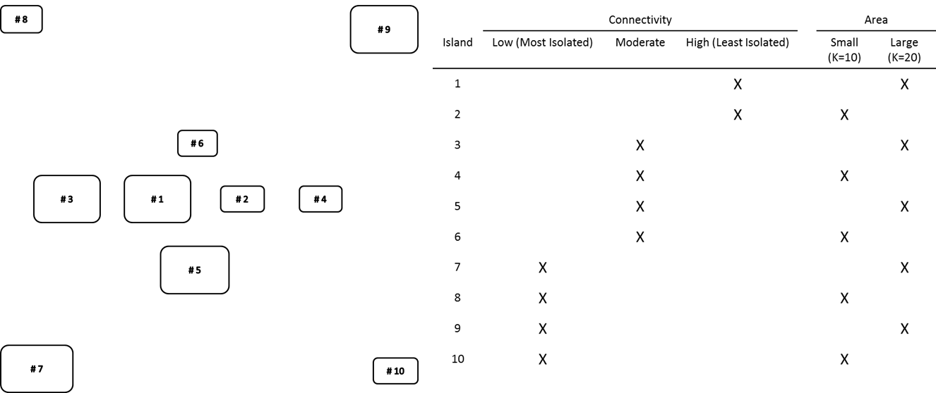

Figure 1. Layout and Characteristics of Islands. Islands are represented by rounded rectangles. In the table, K is the carrying capacity, and initial community size, of the island.

You will notice bags of candy (or marbles) in your bin. Each bag represents one individual within your community that belongs to the species indicated by the picture label on the bag. Within the bags, you have various candies and/or marbles – these represent the allelic composition of your individuals. Note on the datasheets the species richness of your community, and allelic richness of your populations.

Prior to the First Round:
Calculate initial species richness. For each species in your community, record the number of individuals on the Species Richness Datasheet. See below example:

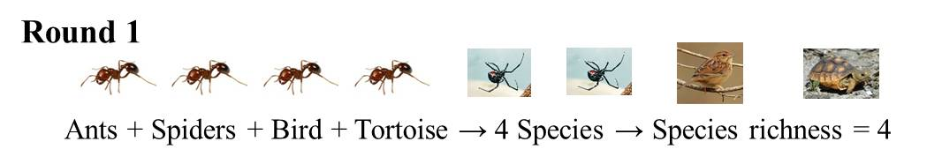
Figure 2a. Calculating initial species richness.

Round | Ant | Bear | Bird | Frog | Snake | Spider | Tortoise | Species richness
1 | 4 |  | 1 |  |  | 2 | 1 | 4
Figure 2b. Initial species richness table.

Calculate initial allelic richness. Different colors of the same candy are considered unique alleles, e.g., a red jolly rancher and a green jolly rancher are different. Count the number of copies of each allele present within each species. Record this information on the Allelic Richness Datasheet. Using the Average Allelic Richness Datasheet calculate the average number of alleles in the community (out of the total number of species included in the game). The example below shows colored dots in the squares that represent different alleles):

Figure 2c. Calculating initial allelic richness
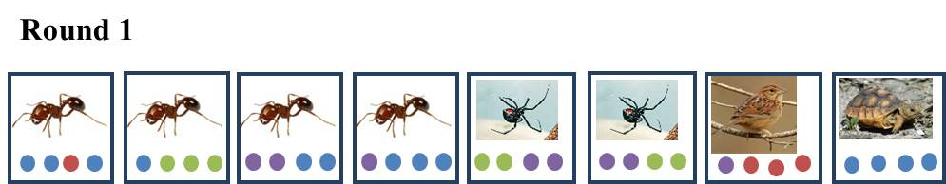

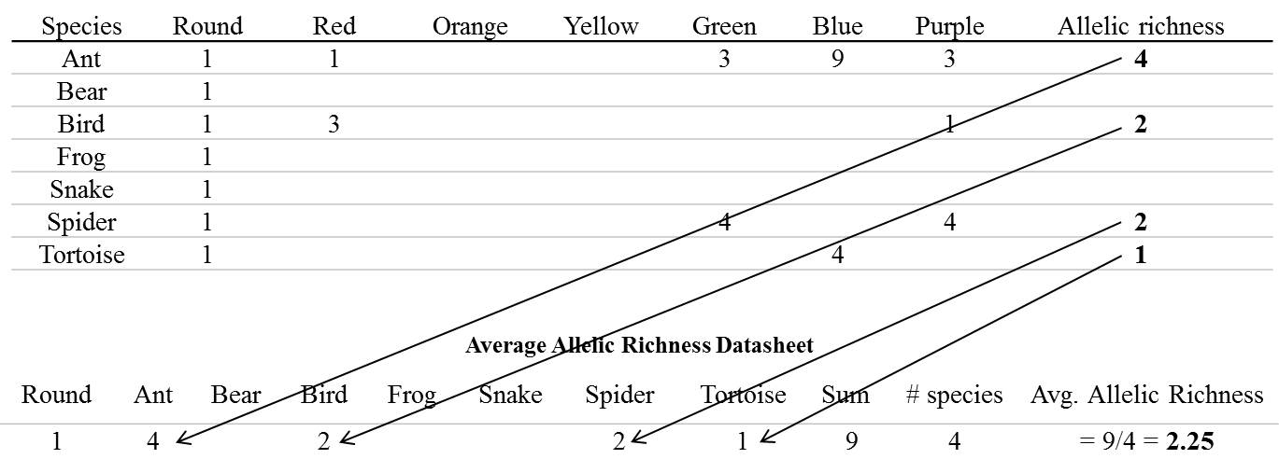Figure 2d. Initial allelic richness tables.

Each Round:
Colonization:
Randomly select an individual from your community to disperse. Simulate a dispersal event by tossing your selected individual toward any community within an uninterrupted linear path (if you have to throw over someone’s head, then it is off limits – review Figure 3 to double-check which islands you can toss to). The tossed individual successfully colonizes the new community if it lands in a bin. If the tossed individual is not successful in its colonization attempt (does not land in a bin), the individual is considered deceased and removed from the activity.

Drift (reproduction and mortality):
Randomly select one individual from your community to reproduce. Due to random chance, this may be the same individual you selected for colonization. This is acceptable. Using the materials available from your instructor, create an identical individual (same species and same alleles). Add both the original and reproduced individual back into your community. If your community now exceeds K, randomly select and remove (representing mortality events) the number of individuals necessary to bring your community size equal to K. The random differential reproductive success and mortality of some individuals over others results in ecological and genetic drift, the loss of species and alleles due to random chance.

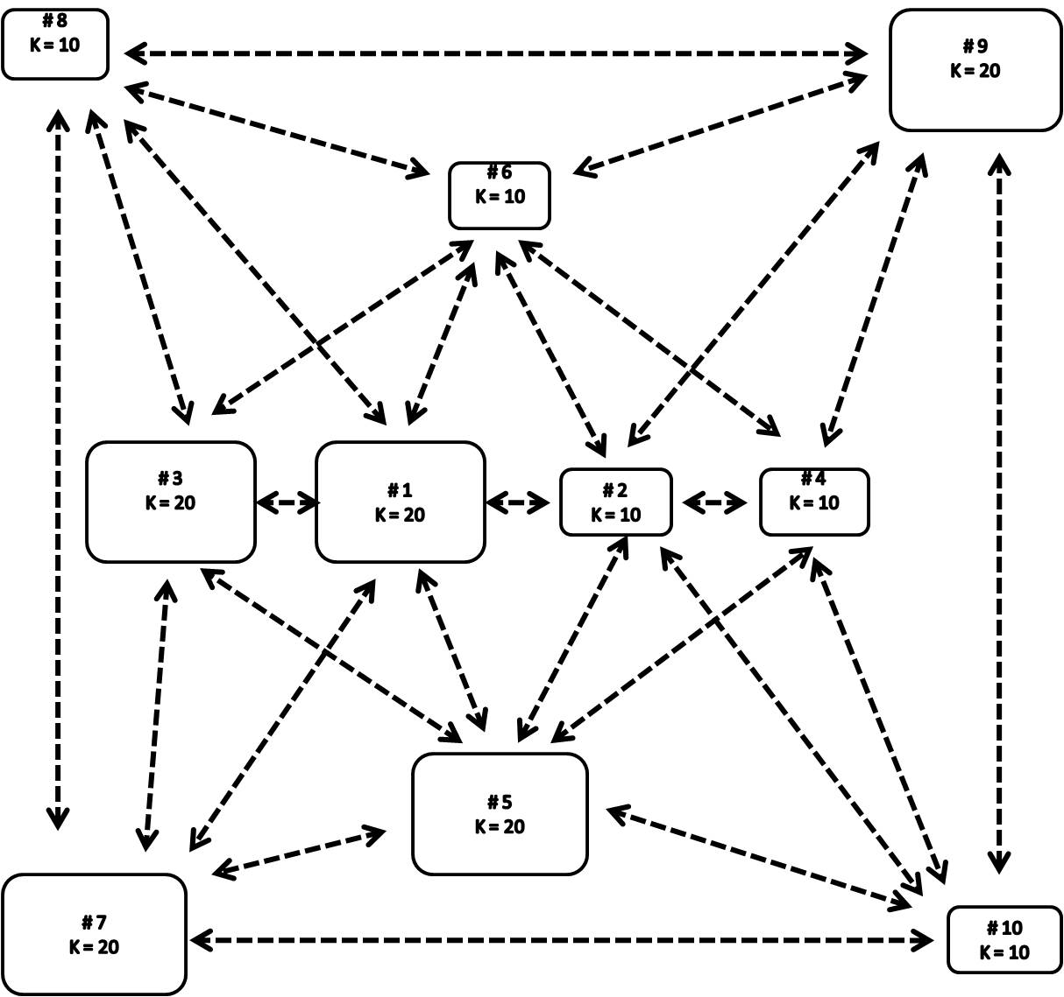
Figure 3. Dispersal routes

After Each Round:
As demonstrated in Figures 4a and 4b, on the Species Richness Table and Allelic Richness Table record the species and alleles lost from your community due to dispersal and mortality, as well as species and alleles added to your community by reproduction and colonization. After one individual from each island has dispersed, record the species and alleles lost from the community. Similarly, for any new immigrants into the community, record the species and alleles gained as explained below:

Species Richness

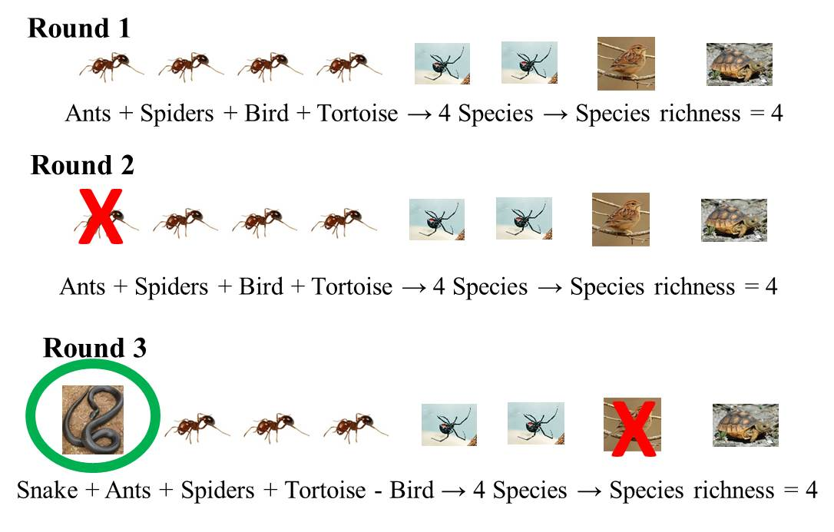
Figure 4a. Calculating species richness

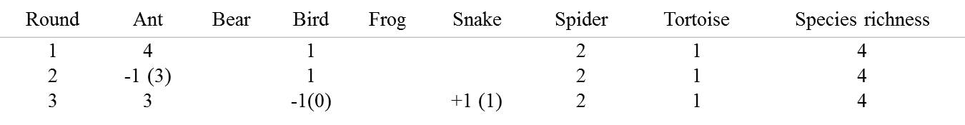
Figure 4b. Species richness table.
Allelic Richness
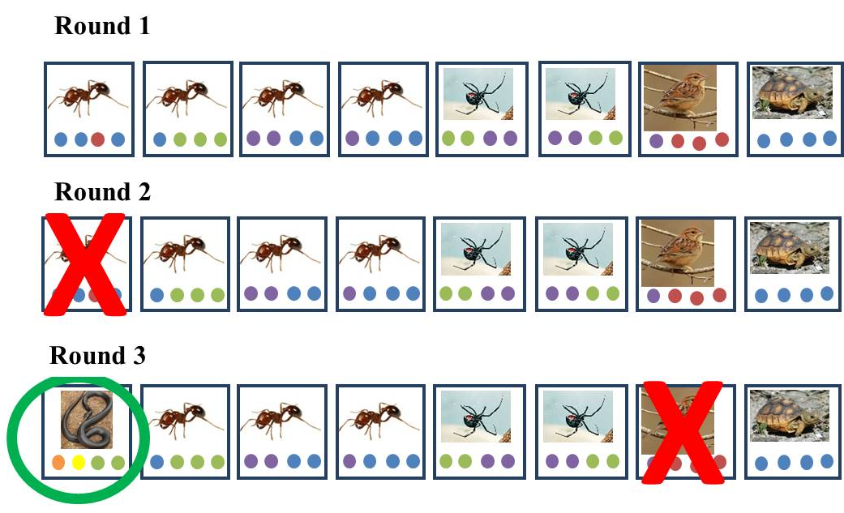
Figure 4c. Calculating allelic richness.

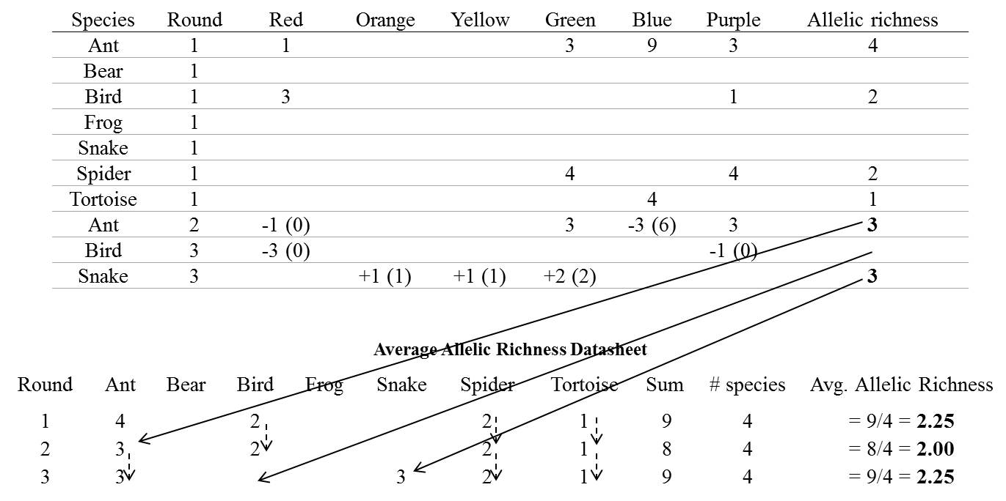

Figure 4d. Allelic richness table

Repeat this process until you have completed ten rounds.

After the Activity:
The class data will be compiled and provided to you in graphs. Part of your homework assignment will be comparing your hypotheses with the class results.

Questions for Further Thought and Discussion:

Discussion questions for after the activity:
- Give two additional examples of systems, besides islands, to which these concepts of drift and colonization could be applied.

- In the reproductive step, was this reproduction sexual or asexual? (i.e., was there genetic combination/sexual outcrossing or not?) How would the dynamics of genetic drift have differed if the reproductive method had differed (sexual as opposed to asexual reproduction or vice versa)?

- Refer to Figure 1. Assuming you have no information about the islands besides their size and location, If you were a natural resources manager and responsible for selecting three islands to protect for biodiversity conservation a) which three would you select and b) why would you select these three?
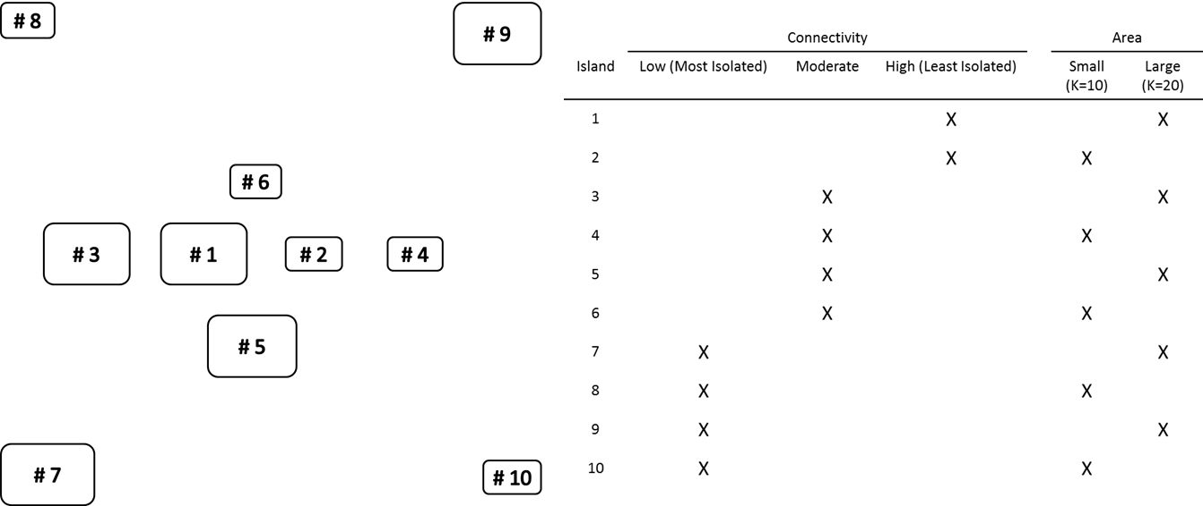
Figure 1. Layout of the islands, represented by rounded rectangles. The top number within each rectangle represents the island ID. The bottom number represents the carrying capacity (K) and the initial size of the community.

- In the real world, other factors besides drift and colonization affect distributions of biodiversity. a) What factors besides drift and colonization affect distributions of species and allelic richness? b) How might you determine whether or not these other factors have stronger effects on species and/or genetic diversity compared to the neutral processes of drift and colonization?

References and Links:

Hu, X. S., F. He, and S. P. Hubbell. 2006. Neutral theory in macroecology and population genetics. Oikos 113:548-556.

Kimura, M. 1968. Evolutionary rate at the molecular level. Nature 217:624-626.

MacArthur, R. H. and E. O. Wilson. 1967. The Theory of Island Biogeography. Princeton University Press, Princeton, New Jersey.

Sax, D. F. and S. D. Gaines. 2011. The equilibrium theory of island biogeography. Chicago: University of Chicago Press.

Vellend, M. 2004. Parallel effects of land-use history on species diversity and genetic diversity of forest herbs. Ecology 85:3043-3055.

Tools for Assessment of Student Learning Outcomes:
Student mastery of the material is assessed by grading answers to discussion questions answered outside of class. To reinforce primary concepts and test for students’ ability to apply the material to different systems, the first three questions for the homework assignment are similar to the questions discussed after the activity in class. Additionally, the material (terminology and/or concepts) may be covered on exams. The questions below add to a total of 15 points.

- Compare your hypotheses to the class results for how species and allelic richness changed over time on small versus large islands. If the results were different than what you expected, explain (and justify) whether you think this was a matter of sampling error or why you think your hypotheses were not supported by the data.. (1 point)

1 point – This answer will depend on whether or not the results agreed with the original hypothesis. However, the response should make sense given the class results.

- Compare your hypotheses to the class results for how species and allelic richness changed over time on isolated versus well-connected islands. If the results were different than what you expected, explain (and justify) whether you think this was a matter of sampling error or why you think your hypotheses were not supported by the data.. (1 point)

1 point – This answer will depend on whether or not the results agreed with the original hypothesis. However, the response should make sense given the class results.

- Explain why the concepts of drift and colonization can be applied to other systems besides islands. (1 point)

1 point –Movement among habitat patches (habitat islands) requires dispersal across suboptimal habitat, and larger patches are likely to have more resources than smaller patches – similar characteristics that describe islands.

- Refer to Figure 5 below. Pretend you’re working as an environmental consultant to a resort development company. The company is building the resort in an undeveloped area and wants to minimize the impact of construction on biodiversity in the area. The company has proposed three optional designs for habitat reserves on the property, and you are responsible for selecting which design will maximize species and allelic richness. Without any other information besides relative size and location, which reserve arrangement would you recommend and why? (1 point)
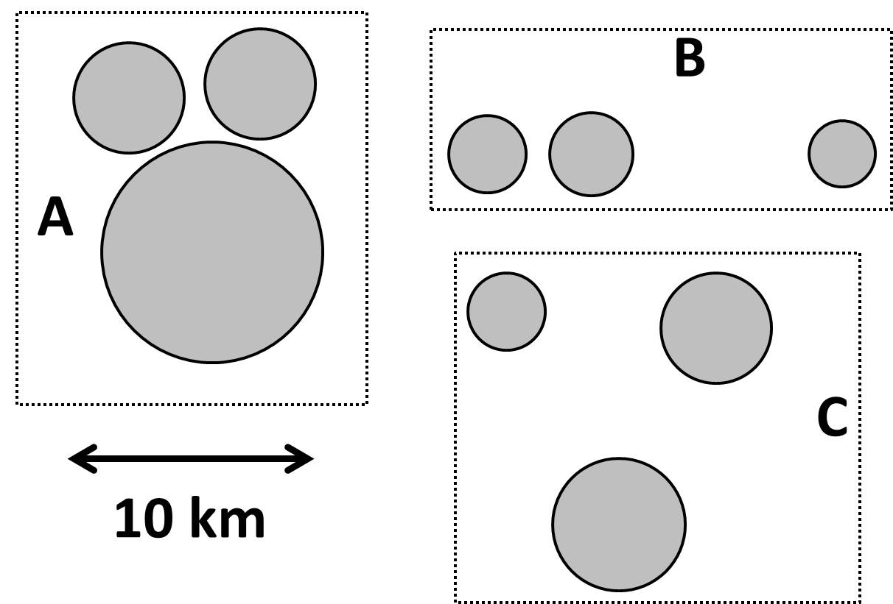
Figure 5. Potential island layouts for conservation.

1 point – A (the design with the largest area and greatest connectivity)

- In the real world, other factors besides drift and colonization affect distributions of biodiversity. a) What factors besides drift and colonization affect distributions of species and allelic richness? And, b) how might you determine whether or not these other factors have stronger effects on species and/or allelic richness compared to the neutral processes of drift and colonization? (2 points)

1 point – a) Selective forces e.g., species interactions and habitat preferences, etc.

1 point - b) If species and/or allelic richness were not positively correlated with area and/or negatively correlated with increasing isolation, or if a null relationship existed between richness and area, and richness and isolation, this would suggest that other selective factors may be influencing the distributions of species and genetic diversity

See Appendix 3 for Sample Exam Questions (Questions 1-15).

Extension Activities for Advanced Students:
- Collect all the data sheets from the students after the activity, graph the results, and provide these graphs to students for interpretation. The calculations may be a bit confusing and some students may have a difficult time understanding this within the lab period. Advanced students may have more success doing the calculations and graphing on their own, possibly making this an appropriate additional activity for advanced students. Additionally, the activity could be repeated multiple times, with slight modifications each time to demonstrate effects of differing scenarios, within a class period. An example of a modification that could be made to the activity would be to incorporate a selective component that affects dispersal abilities, thereby affecting colonization rates. Heavier bags are easier to toss farther and more accurately, so one way to represent this in the activity would be to add extra weight to the bags of some species, but not others.

NOTES TO FACULTY
At the beginning of the activity, when students are asked to write out and graph their hypotheses, we recommend using this as a think-pair-share opportunity. To make sure students have an idea of what they are supposed to do, we go over the first verbal and graphical hypotheses (the effect of island size on changes in species richness over time) as a class. Then, we have students work with a partner to come up with the verbal and graphical hypotheses for the effect of island size on allelic richness over time. Students then take turns sharing their verbal and written hypotheses with the class. We help clarify any confusion students may have, then have them think-pair-share for the hypotheses pertaining to the effects of connectivity on species and allelic richness.

We generally precede this activity with one or two days of lecture on evolution and island biogeography. In addition to covering mutation and natural selection in the evolution material, extra time was spent discussing the effects of genetic drift and gene flow on genetic diversity in populations so that students are comfortable with these terms going into the activity. We also assign several readings from the book, Song of the Dodo, a non-fiction book on island biogeography.

Although it is not essential to understanding the concepts of neutral evolutionary and ecological processes, we generally begin the lab with a discussion on the constituents of biodiversity (ecosystem, species, and genetic diversity) and the importance of biodiversity to human existence. This approach puts the relevance of the activity to the students’ own existence into context.

The part of the activity where students are supposed to generate verbal and graphical hypotheses is an excellent opportunity for think-pair-share, where students brainstorm hypotheses by themselves, then pair up with a partner or small group and discuss their hypotheses. Groups then share their answer(s) with the class, at which point the teacher can help clarify any misunderstandings or confusion the students may have.

We have not tried alternatives to candy as representatives as alleles. However, any colored objects that can fit inside the plastic baggies (e.g., beads, marbles or buttons) should work. If candy is used, we bring extra candy for students to eat and make sure they understand the candies in the bags are being used in the activity and are not for their consumption.

Be sure to include enough variation at the genetic level that students can see changes in allelic richness, but not so much variation that it is difficult to keep up with outgoing and incoming alleles. This approach is also recommended at the species level. We generally use nine to ten different species (Figure 1) and nine to ten different alleles, as they are manageable levels for students to record.

Remind students to be aware of others when they are tossing the candy. We recommended, prior to the activity, stating consequences of hitting someone with a bag of candy – on purpose or by accident –to avoid potential injuries.

Our students have found data recording easier if they keep their bags outside of the bins, so when they receive an immigrant, they do not have trouble keeping track of which individual entered the community.

As the objectives of this activity are related to student understanding of the material, as opposed to data entry and learning graphing programs, we collected the student data sheets and compiled and graphed the results, to make the most effective use of student time. However, if this activity were conducted for an advanced level class, requiring the students to perform their own species and allelic richness calculation and graph the results would add an element of complexity to the activity.

One of the benefits of conducting a simulation activity in class is the heuristic opportunity for students when activity results do not follow expectations. This activity is supposed to represent a model of community and population dynamics with equal colonization and extinction rates among ponds, random dispersal/gene flow among islands, and no selection in favor of or against specific species or alleles. If the results of the activity do not follow expectations, we recommend 1) asking students to think about the assumptions implicit in the activity model, 2) discuss which assumptions may not have been met during the activity, and 3) suggest how the activity could be modified to meet those assumptions. This helps students understand that models are simplified abstractions of how we think a system behaves, and that each component of the activity represents part of that abstraction. For example, in our classes, the results of the activity never converged on expectations (i.e., none of the communities ever reached a colonization-extinction equilibrium) and all communities neared total extinction or became extinct. One possible reason for this was that in our classes we had not included a reproduction step to regenerate individuals and alleles in the community. One way to incorporate a reproduction step in each round was to randomly select one individual from the community and create a replicate individual of the same species and with the same alleles to add to the community.

We initially assigned all students to perform a literature review. For this activity, students worked with the members of their group to find five to seven peer-reviewed journal articles that investigated the effect of neutral factors (i.e., area and isolation) and non-neutral factors (e.g., habitat features) on species and allelic richness. For each paper we had them describe the taxa investigated, what the habitat patches were, which predictor variables of species and/or allelic richness were investigated, the results of the study in terms of which predictor variables were most strongly and/or closely associated with richness, and the directional relationship (positive or negative) between richness and these predictor variables. Then based on the results of the articles, we asked them to assess the relative importance of drift and colonization compared to other factors (e.g., habitat selection, competition) for determining distributions of species or genetic diversity; and to justify their opinion with examples from the results of the studies. An example of one student’s response to this assignment is provided in the section, “Sample Student Written Responses to Homework Assignments.”

The intent of this activity was to demonstrate that area and/or isolation may be determinants of richness, however the relationship between diversity and these variables may not be as expected; other factors besides area and/isolation may affect distributions of richness. Based on student responses, most students were still under the impression that area and isolation were the only factors affecting richness distributions. To help get these points across to students, we recommend assigning specific articles (see below for suggestions, summary of results listed in Appendix 4) that demonstrate how the strength and direction of effects of neutral and non-neutral factors on species and allelic richness can vary considerably. We also recognize asking students to assess the relative importance of the processes of drift and dispersal on species and allelic richness based on the results from their literature review may send a message to students that such an assessment is possible from as few as five journal articles. We therefore recommend an alternative to assigning students to assess the importance of drift and dispersal on species and allelic richness. Instead, students should be assigned to hypothesize for one, several, or all of the articles, what would happen to species and/or allelic richness if managers chose to protect only the large patches, or only the well-connected patches without consideration of other factors, such as habitat diversity. Additionally, we recommend discussing the results of these papers in class, and making sure students understand that, in some cases, area and isolation are primary determinants of richness; however this is certainly not an absolute, nor is the direction of effect of area and isolation.

Banks, S., G. Finlayson, S. Lawson, D. Lindenmayer, D. Paetkau, S. Ward, and A. Taylor. 2005. The effects of habitat fragmentation due to forestry plantation establishment on the demography and genetic variation of a marsupial carnivore, Antechinus agilis. Biological conservation 122:581-597.

Hamer, T.L., C.H. Flather, and B.R. Noon. 2006. Factors associated with grassland bird species richness: the relative roles of grassland area, landscape structure, and prey. Landscape Ecology 21:569-583.

Krauss, J., A.-M. Klein, I. Steffan-Dewenter, and T. Tscharntke. 2004. Effects of habitat area, isolation, and landscape diversity on plant species richness of calcareous grasslands. Biodiversity and Conservation 13:1427-1439.

Lindsay, D.L., K.R. Barr, R.F. Lance, S.A. Tweddale, T.J. Hayden, and P.L. Leberg. 2008. Habitat fragmentation and genetic diversity of an endangered, migratory songbird, the golden‐cheeked warbler (Dendroica chrysoparia). Molecular Ecology 17:2122-2133.

Scribner, K.T., J. Arntzen, N. Cruddace, R. Oldham, and T. Burke. 2001. Environmental correlates of toad abundance and population genetic diversity. Biological conservation 98:201-210.

Steffan‐Dewenter, I. 2003. Importance of habitat area and landscape context for species richness of bees and wasps in fragmented orchard meadows. Conservation Biology 17:1036-1044.

Struebig, M.J., T. Kingston, E.J. Petit, S.C. Le Comber, A. Zubaid, A. Mohd‐Adnan, and S.J. Rossiter. 2011. Parallel declines in species and genetic diversity in tropical forest fragments. Ecology Letters 14:582-590.

Challenges to Anticipate and Solve

1. Confusion About How to Record the Data and Calculate Richness (species and allelic): Some students have a difficult time keeping track of allelic richness for each species after the first round. To keep the activity moving along and minimize work outside of the class, students were only asked to record the species and alleles entering and leaving communities and we calculated species and allelic richness and provided students with the graphs. However, if you would prefer for your students to perform the calculations and create their own graphs, this could be done after the lab, following the examples in the handout. Students could also just graph the results from their own island, and predict what the results from islands with differing characteristics (size and isolation) would look like graphically relative to their results.

2. The Random Selection of Individuals and Dispersal Routes: To ensure students are randomly selecting which individuals from their community disperse, reproduce, and (if applicable) die, ask students to “stir” their communities between rounds, and close their eyes when selecting individuals. The only directions we gave to students regarding which islands they could disperse to were that students were not allowed to toss any individuals across the path of other students, primarily for safety purposes. Given the larger bins are closer together and are easier for students to make compared to smaller and more isolated bins, we were not concerned about students randomly selecting the receiving bins. However, if absolute randomization of dispersal routes is a concern, one way to accomplish this would be to have students randomly draw target bin numbers from a bag or roll dice.

3. Occupying Spare Time: The well-connected and moderately-connected islands are likely to receive more immigrants than the isolated islands (if the activity is working as it should). Therefore students at these more connected islands will require more time to record data than the students at the isolated populations. To keep students at these isolated islands engaged while other students are busy recording data, provide them with either the questions for further discussion and ask them to brainstorm answers while they wait, or to ask additional questions, such as what sort of adaptations have species developed to facilitate long-distance dispersal events? Alternatively, these students could work on calculating average allelic richness after each round. Similarly, if you are working with a large class and have three to four students per group, students can rotate through the roles of recording species data, recording genetic data, removing and tossing the randomly selected baggie, and brainstorming responses to the discussion questions

4. Theoretical Versus Real Systems: This activity ignores the ecological differences among species, such that there are no consequences of selection or species interactions. This could be incorporated into the activity, for example by selectively removing certain species or alleles from the communities each round. Instead of incorporating a selection into the game, we chose to include discussion questions that encourage students to think about other forces that determine distributions of species and genetic diversity. Additionally, with the literature review, students are likely to encounter studies where species and/or allelic richness were associated with habitat variables as opposed to habitat size and/or isolation.

Comments on Introducing the Experiment to Your Students:
During the lab, but prior to the activity, we introduce the concepts in the activity by discussing island biogeography and the effects of island size and isolation on species diversity during the same lab period. We review the concepts of genetic drift and colonization and their effects on genetic diversity in populations.

Comments on the Data Collection and Analysis Methods Used in the Experiment:
Prior to starting the activity, we strongly recommend working through an example of how to record outgoing and incoming species and alleles. Also, we recommend making sure students understand why they are recording the cumulative number of individuals for a given species, and cumulative number of alleles for a given species (so each round they only have to count the individuals that are removed or added to the community, as opposed counting all individuals and alleles each round). By keeping track of the number of individuals per species and the number of each allele for each species, students know when that species or allele has become extinct from the community or population, respectively. After the first round in the activity, check with students to make sure they’re comfortable with how to record the data.

We used pre and post surveys to test whether the activity was helping students to meet the objectives. We suggest this be done in other classrooms as well, to ensure students are gaining knowledge through the activity, and meeting the objectives outlined in the activity.

Comments on Questions for Further Thought and Discussion:
- Give two additional examples of systems, besides islands, to which these concepts of drift and colonization could be applied.

Example answers include mountaintops, heads of coral, forest fragments, wetlands, national parks, etc.

Question purpose: Help students understand neutral ecological forces on islands behave the same as neutral ecological forces in habitat patches/islands

Students typically do not have any problem making the connection between islands and other patchy habitat types.

- In the reproductive step, a) was this reproduction sexual or asexual? (i.e., was there genetic combination/sexual outcrossing or not?) b) How do you know? c) How would the dynamics of genetic drift have differed if the reproductive method had differed (sexual as opposed to asexual reproduction or vice versa)?

Example answer: Reproduction is asexual because the genotypes of the offspring are exact copies of the parents. Recombination would occur if the reproduction had been sexual. With asexual reproduction, the probability of an allele going extinct is a function of the frequency of individuals with that allele, whereas with sexual reproduction, the probability of an allele going extinct is a function of the frequency of the allele.

Question purpose: Help students recognize one of the assumptions/limitations of the activity, and get students thinking about how the results might differ for sexually reproducing species

If students have trouble answering these questions, we recommend going over an example in class, either on the board or with colored beads, etc. This may help students visualize that with recombination, the probability of an allele being included in the next generation would be a function of its frequency in the population, as opposed to the proportion of individuals in the population with the allele, as is the case without recombination.

- Refer to Figure 1. Assuming you have no information about the islands besides their size and location, If you were a natural resources manager and responsible for selecting three islands to protect for biodiversity conservation a) which three would you select and b) why would you select these three?

Figure 1. Layout and Characteristics of Islands. Islands are represented by rounded rectangles. In the table, K is the carrying capacity of the island.

Example answer: Islands 1, 3, & 5 are the largest and most well-connected islands, and would minimize drift while maximizing colonization among the islands.

Question purpose: Ensure students understand how the concepts of drift and colonization can be applied to habitat reserve design

Students typically do not have any problem answering these questions. Typically student responses for question b include that larger islands are more likely to have greater richness because there are likely to be more resources, and colonization is more likely to occur among the islands that are closer to each other.

- In the real world, other factors besides drift and colonization affect distributions of biodiversity. a) What factors besides drift and colonization affect distributions of species and allelic richness? b) How might you determine whether or not these other factors have stronger effects on species and/or genetic diversity compared to the neutral processes of drift and colonization?

Example answer:
a) Selective forces e.g., such as species interactions and habitat preferences, etc.
b) If species and/or allelic richness were not positively correlated with area and/or were not negatively correlated with increasing isolation, this would suggest that other selective factors had stronger effects on the distributions of species and genetic diversity

Question purpose: Help students recognize that drift and colonization are not the only forces that affect the distributions of species and genetic diversity. However, they are the only forces that lead to predictable outcomes across taxa

Students often understand that selective processes, competition, predation, etc. influence distributions of richness; however they are often confused by the second half of the question. If this is the case, another way to phrase the question might be, “richness is generally positively correlated with area, and negatively correlated with isolation when drift and colonization are the primary process dictating distributions of species and allelic richness. How might these relationships differ if non-neutral processes are the primary determinants of diversity distributions?”

Comments on the Assessment of Student Learning Outcomes:
- Compare your hypotheses to the class results for how species and allelic richness changed over time on small versus large islands. If the results were different than what you expected, explain (and justify) whether you think this was a matter of sampling error or why you think your hypotheses were not supported by the data..
1 point – This answer will depend on whether or not the results agreed with the original hypothesis. However, the response should make sense given the class results

Question purpose: Help students interpret graphical data to understand the class results. Additionally, students can also compare their original graphical hypothesis to the class results, to help remind them of what the graphical relationship should look like

Sample student response: Our hypothesis was that over time, species richness would decrease linearly in both the small and large islands. In our experiment, we did see this happen but not on such a steep scale. Our hypothesis was over much more than ten generations – which is how long we continued our experiment – which means that eventually our experimental population will reach our hypothesized levels. As we take species out of our population and “throw” them into new islands, we lose species richness, and say if we are a small island where it is very hard for species to make it to, then you are losing species and not gaining any to replace it, thus the species richness for the smaller island drops at a higher rate than the larger island.

- Compare your hypotheses to the class results for how species and allelic richness changed over time on isolated versus well-connected islands. If the results were different than what you expected, explain (and justify) whether you think this was a matter of sampling error or why you think your hypotheses were not supported by the data..
1 point – This answer will depend on whether or not the results agreed with the original hypothesis. However, the response should make sense given the class results

Question purpose: Help students interpret graphical data to understand the class results. Additionally, students can also compare their original graphical hypothesis to the class results, to help remind them of what the graphical relationship should look like

Sample student response: Our hypothesis in regards to allelic richness stated the larger islands (or ponds) would have a higher allelic richness initially and that they would lose alleles from their population slower than the small islands. This hypothesis was supported by our experimental data. As the generations go on, the allelic richness of the small islands drops steadily over time, whereas the allelic richness of the large population falls slightly and then remains rather constant. This result goes back to the explanation from question 2. When the small island loses a species, it loses those alleles from the population and then it is harder for a small island to receive more or new species, thus they are giving away alleles from their population and not receiving any new ones to take their places.

- Explain why the concepts of drift and colonization can be applied to other systems besides islands.
1 point – Movement among habitat patches (habitat islands) requires dispersal across suboptimal habitat, and larger patches are likely to have more resources than smaller patches – similar characteristics that describe islands

Question purpose: Help students understand the basis for the application of island biogeography to alternative systems

We have not asked students this question in the past; however, we believe it is important that students are able to understand that the connection is based on suitable versus unsuitable habitat.

- Refer to Figure 5 below. Pretend you’re working as an environmental consultant to a resort development company. The company is building the resort in an undeveloped area and wants to minimize the impact of construction on biodiversity in the area. The company has proposed three optional designs for habitat reserves on the property, and you are responsible for selecting which design will optimize species and allelic. Without any other information besides relative size and location, which reserve arrangement would you recommend and why?
Figure. 5. Potential islands for conservation.

1 point –A –This reserve design has the largest habitat patches (lower rates of drift) and greatest connectivity (greater rates of colonization)

Question purpose: Ensure students understand how the concepts of drift and colonization can be applied to habitat reserve design

Students generally do not have any issues selecting which habitat reserve has the optimal design for maximizing biodiversity assuming drift and colonization are the only processes affecting biodiversity. Student explanations for their selection generally mention that option A maximizes dispersal among islands because of their proximity to each other and minimizes drift because this option includes islands with the greatest area.

- In the real world, other factors besides drift and colonization affect distributions of biodiversity. a) What factors besides drift and colonization affect distributions of species and allelic richness? b) How might you determine whether or not these other factors have stronger effects on species and/or allelic richness compared to the neutral processes of drift and colonization? (Hint: consider the hypotheses you generated at the beginning of the activity, and how those hypotheses would differ if non-neutral factors had stronger effects than neutral factors)
1 point – a) Selective forces e.g., species interactions and habitat preferences, etc.

1 point - b) If species and/or allelic richness were not positively correlated with area and/or negatively correlated with increasing isolation, this would suggest that other selective factors were influencing the distributions of species and genetic diversity

Question purpose: Help students recognize that drift and colonization are not the only forces that affect the distributions of species and genetic diversity, and that the effects of non-neutral forces on diversity can be unpredictable, masking the predicted relationship between neutral factors and diversity.

In the past, we used these questions for in-class discussion purposes only, without requiring students to think about them outside of class. Given the importance of students understanding that the activity made the unrealistic assumption that drift and colonization as the only forces affecting distributions of biodiversity, we chose to emphasize this point by including these questions in the homework as well.

Comments on Formative Evaluation of this Experiment:
*Note – we present only results from consenting undergraduate students who were present for both the first and second round of surveys.

This activity was conducted in two semesters of an upper level undergraduate ecology course, and one semester in a split-level (upper level undergraduate and graduate) course. During the development of this activity, we created a survey with questions in a quiz-like format (True/False and Multiple Choice) to test the effectiveness of this activity at meeting the outlined objectives, to gauge changes in student confidence in their knowledge of the material, and to obtain feedback from students about the activity and areas for improvement (Appendix 3). Students took the survey twice: once prior to the activity during the lecture portion of the class, and then again in lab either immediately before the activity or immediately after the activity. This approach allowed us to compare how changes in knowledge and confidence scores differed between students who had participated in the activity, versus those who had not.

We calculated students’ knowledge as the proportion of questions answered correctly out of the number of questions that were answered, and confidence scores as the average confidence value that students reported for the questions they answered. Our analysis with factorial ANCOVAs demonstrated that participation in the activity significantly improved students’ knowledge of how drift and colonization affect species richness, and generally improved students’ knowledge of the effects of drift and colonization on genetic diversity, although the improvement was not statistically significant (Figure 6a). Participation in the activity also increased students’ confidence in their understanding of the effects of drift and colonization on species and genetic diversity (Figure 6b).

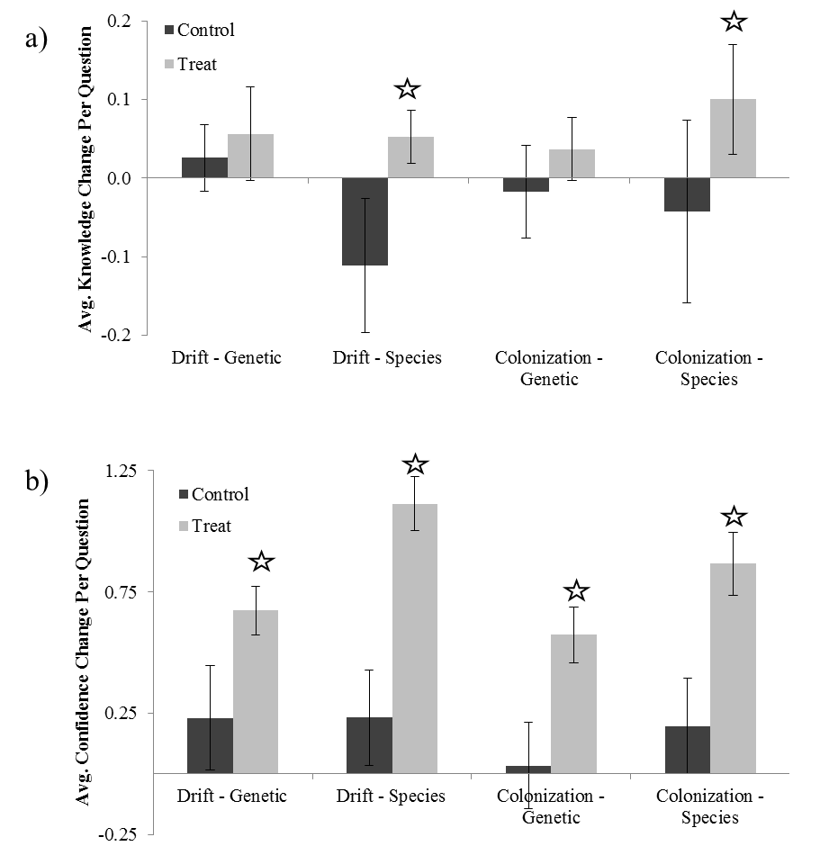
Figure 6. Average change in a) knowledge and b) confidence scores compared to pre-activity averages for survey questions regarding the effects of colonization and drift on species and genetic diversity. Bars represent 95% confidence intervals. Stars indicate significant differences between the control and treatment scores, at alpha = 0.05, after accounting for students’ pre-Activity confidence and knowledge scores.

Comments on Translating the Activity to Other Institutional Scales or Locations:
This activity could be modified for smaller classes by decreasing the number of islands, or be modified for larger classes by either increasing the number of islands or by breaking the class up into two or more groups. If islands are either added or removed, you may wish to think about the arrangement of the islands/bins such that the arrangement has large and small bins distributed at scales of differing connectivity levels. This activity could also be modified to fit other systems that exhibit patchy distributions or systems that occur as metapopulations. Although we have only conducted this activity in upper level undergraduate ecology courses, we believe the activity may translate to lower level undergraduate courses or possibly even be suitable for high school courses, to teach concepts of island biogeography and effects of neutral factors on genetic diversity.

STUDENT COLLECTED DATA FROM THIS EXPERIMENT
We include examples of student-recorded data on the species and allelic richness datasheets (Figures 7 and 8), and graphical representations of results from three classes (Figures 9 and 10). To increase the sample size and reduce the chance of unexpected results from the activity, we recommend compiling data from multiple classes and explaining to students that their data have been added to a larger data set. The graphical results in Figures 9 and 10 were calculated by grouping results from islands with matching characteristics (e.g. large versus small) and calculating the means from these groups.

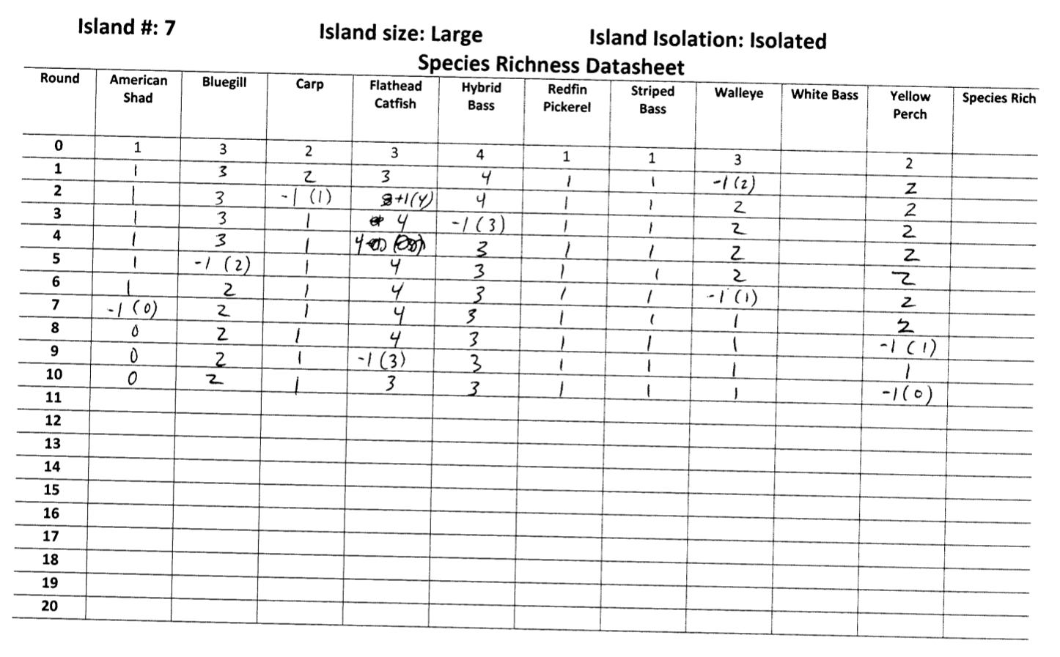
Figure 7. Student completed species richness datasheet

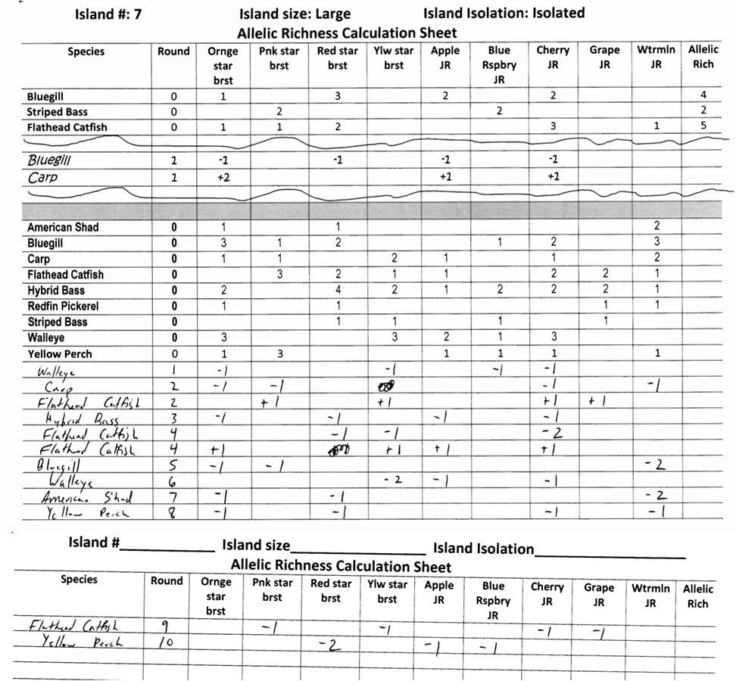
Figure 8. Student completed allelic richness datasheets

a) | 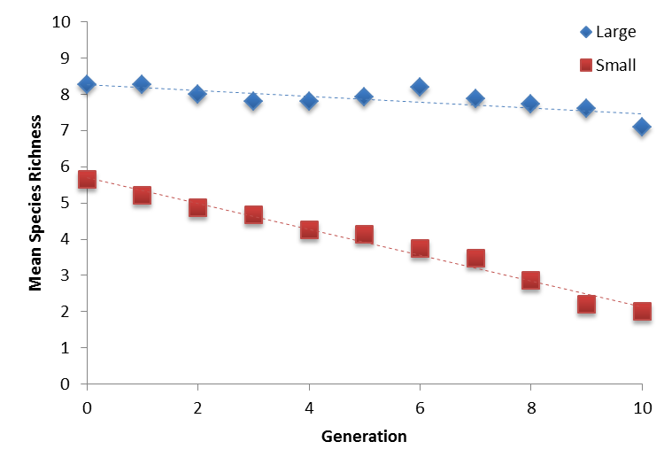
b) | 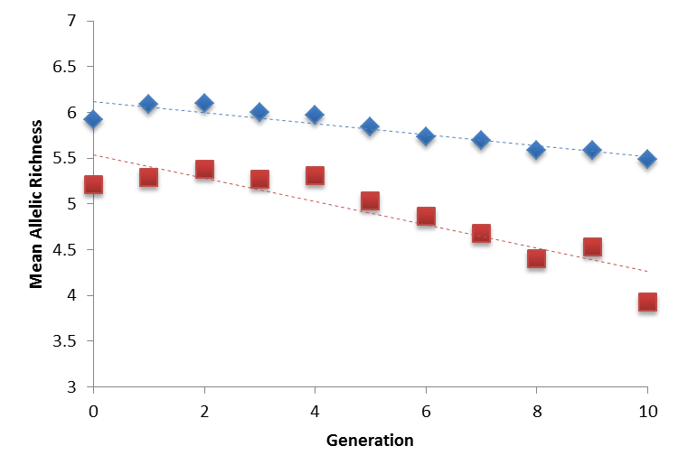
Figure 9. Graphical results for a) mean species richness and b) mean allelic richness by island size (N=15; 3 classes, 5 small and 5 large islands per class), based on data collected from three classes. Standard deviations in species richness values per generation ranged from 1.1 – 1.4 for large islands and 0.9 – 1.3 for small islands. Standard deviations in allelic richness values per generation ranged from 0.50 – 0.97 for large islands and 0.8 – 1.8 for small islands.

a) | 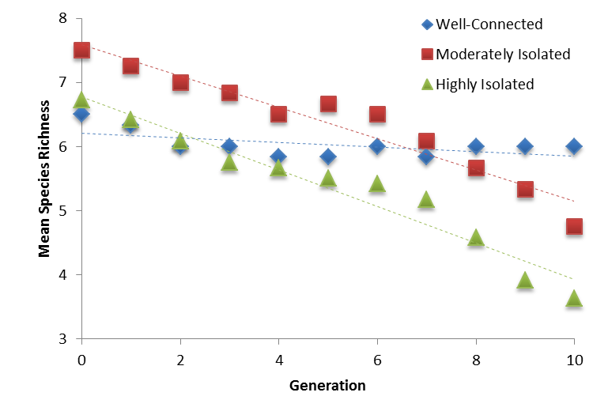
b) | 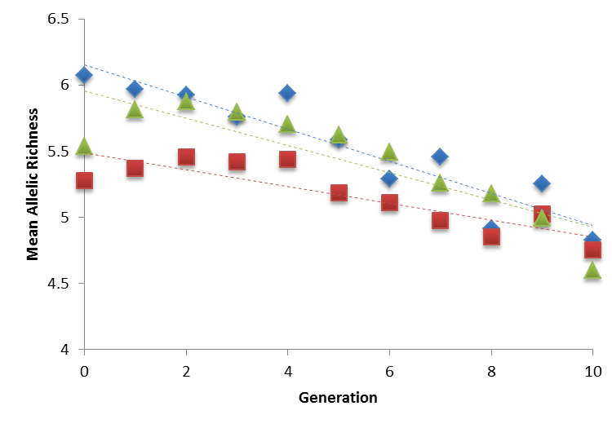

Figure 10. Graphical results for a) mean species richness and b) mean allelic richness by island isolation (N=12 for moderately and highly isolated islands, and N=6 for well-connected islands; 3 classes, 4 moderately isolated islands, 4 highly isolated islands and 2 well-connected islands per class), based on data collected from three classes. Standard deviations in species richness values per generation ranged from 2.1 – 3.8, 1.6 – 2.8, and 1.8 – 3.0 for well-connected, moderately isolated, and highly isolated islands, respectively. Standard deviations in allelic richness values per generation ranged from 0.5 – 1.1, 0.8 – 1.2, and 0.7 – 2.1 for well-connected, moderately isolated, and highly isolated islands, respectively.

Sample Student Written Responses to Homework Assignments

Below are example responses to two different types of homework assignments. The first assignment was related to how the outcome of the activity aligned with the student’s hypotheses: 2) Compare your hypotheses to the class results for how species richness changed over time on small versus large islands. If the results were different than what you expected, explain (and justify) whether you think this was a matter of sampling error or whether you think your hypotheses were incorrect. 3) Compare your hypotheses to the class results for how allelic richness changed over time on small versus large islands. If the results were different than what you expected, explain (and justify) whether you think this was a matter of sampling error or whether you think your hypotheses were incorrect. 4) Based on your hypotheses and/or the class results from the activity, what do you think the relationship is between the effect of island size on species richness and the effect of island size on allelic richness? 5) Compare your hypotheses to the class results for how species richness changed over time on isolated versus well-connected islands. If the results were different than what you expected, explain (and justify) whether you think this was a matter of sampling error or whether you think your hypotheses were incorrect. 6) Compare your hypotheses to the class results for how allelic richness changed over time on isolated versus well-connected islands. If the results were different than what you expected, explain (and justify) whether you think this was a matter of sampling error or whether you think your hypotheses were incorrect. 7) Based on your hypotheses and/or the class results from the activity, what do you think the relationship is between the effect of island isolation on species richness and the effect of island isolation on allelic richness?
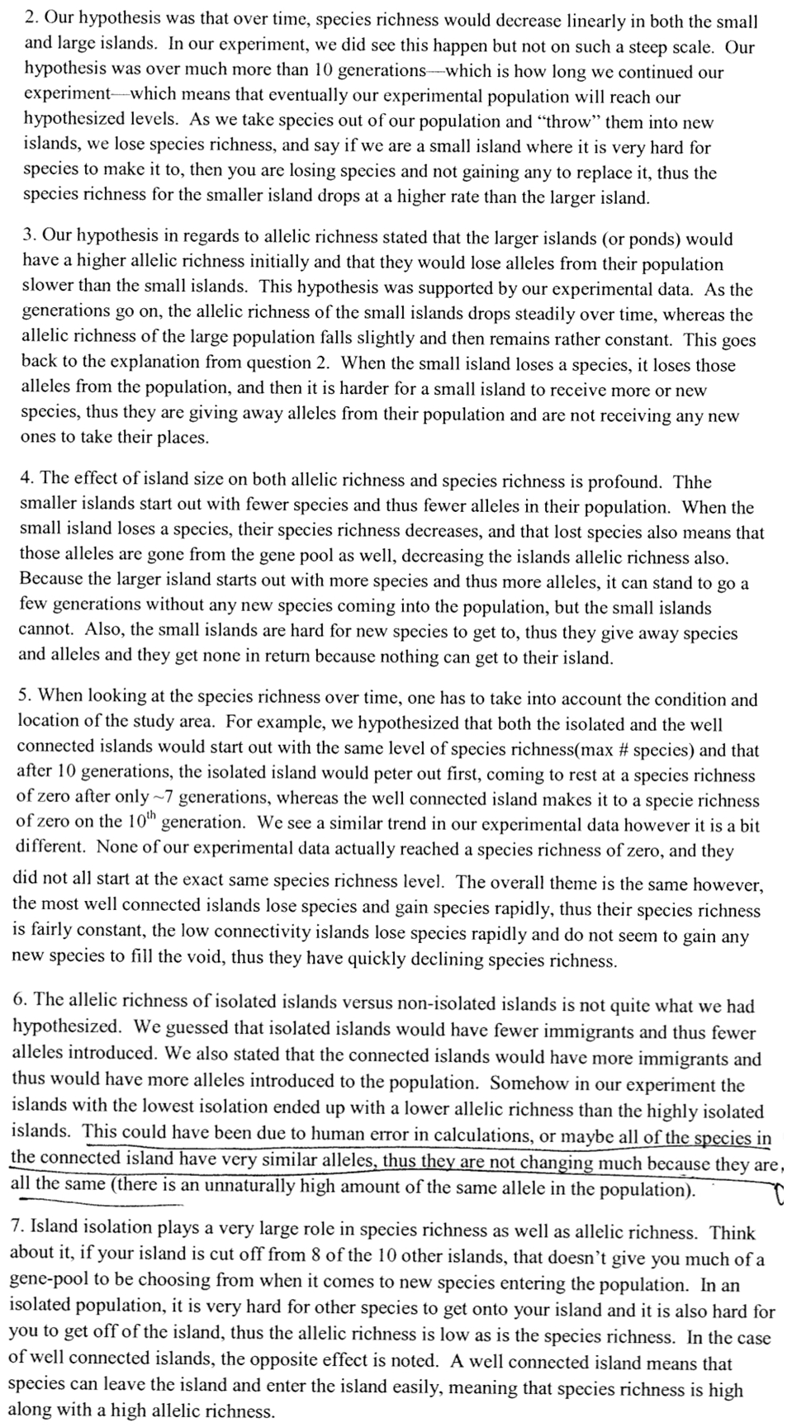
The second example is from an assignment for students to find five peer-reviewed journal articles that investigate the relationship between habitat area and richness (species OR allelic) and the relationship between habitat isolation and richness (species OR allelic). For each paper the students were to: a) describe the taxa investigated - amphibians, birds, vertebrates, etc., b) describe what the habitat patches were - islands, wetlands, mountain tops, national parks, etc., and c) summarize the results of the study in terms of whether or not correlations were found between richness and area/isolation. If correlations were found, students were to include whether they were positive or negative. Based on the results of the five articles, the students were then to describe how important they thought the processes of drift and colonization are for determining distributions of species OR genetic diversity?

- Johnson WE, Godoy JA, Palomares F, et al. (2004). Phylogenetic and phylogeographic analysis of Iberian lynx populations. Journal of Heredity 95(1): 19-28.

This paper investigated the impact of population fragmentation on the genetic richness and diversity of the Iberian lynx (Lynx pardinus). The population fragments examined were current national parks as well as historical areas in which the lynx was known to have lived but has since been extirpated. They used museum specimens/remains to collect genetic data on these individuals. The study found that there was low genetic diversity among all of the populations, and the investigators determined that the lack of genetic diversity was due to population bottlenecking caused by habitat fragmentation. This fragmentation allowed for genetic drift and haplotype fixation in certain individual populations. The loss of some of the historical populations was also attributed to the lack of genetic diversity and the inability to immigrate between populations. This shows that the smaller the habitat, the less diversity and overall fitness a population exhibits.

- Bruggeman DJ, Wiegand T, and Fernández N (2010). The relative effects of habitat loss and fragmentation on population genetic variation in the red-cockaded woodpecker (Picoides borealis). Molecular Ecology 19(17): 3679-3691

This paper studied the impact of habitat loss and fragmentation on the red-cockaded woodpecker (Picoides borealis). The habitat areas of interest were forested areas of either high-quality habitat, low-quality habitat, or unforested areas, and the amount of fragmentation ranged from highly fragmented to perfectly contiguous habitats (using simulation modeling). The study found that fragmentation was the leading cause of low genetic diversity compared to population size, although it also showed that a low population size compounded these genetic problems. Population fragmentation had an increasingly negative impact on the amount of genetic diversity as the fragments became smaller and more isolated.

- Zaviezo T, Grez AA, Estades CF, and Peréz A. (2006). Effects of habitat loss, habitat fragmentation, and isolation on the density, species richness, and distribution of ladybeetles in manipulated alfalfa landscapes. Ecological Entomology 31(6): 646-656.

This paper looked at the effects of habitat fragmentation and isolation on the species richness and density of species of ladybeetles/coccinellids (Eriopis connexa, Hyperaspis sphaeridioides, Hippodamia variegata, and Hippodamia convergens). The habitat patches that were studied were alfalfa microhabitats with varying degrees of fragmentation and isolation. This study found that habitat loss had varying impacts on the species richness and abundance in the remaining habitat, and that in this case habitat fragmentation actually had a positive impact on species richness and the density of several coccinellids. The level of isolation that the populations exhibited also did not show any correlation to richness.

- Johnstone CP, Reina RD, and Lill A. (2010). Impact of anthropogenic habitat fragmentation on population health in a small, carnivorous marsupial. Journal Of Mammalogy 91(6): 1332-1341.

The species of interest in this study was the agile antechinus (Antechinus agilis), and it was examined to determine the effect of anthropogenic habitat fragmentation on the health of the population. The study area was a region in southeastern Australia called South Gippsland, and the sites were fragmented by agricultural activities that isolated the native forested areas. This study found that ectoparasite loads were greater in the fragmented habitat areas than in the contiguous forest sites. The study found that this decrease in health was most likely due to habitat fragmentation and that the smaller the area, the more likely the population’s health in that area was to decline. This is a negative relationship between fragmentation and species abundance and genetic diversity.

- Benedick SS, Hill JK, Mustaffa NN, Chey VK, Maryati MM, Searle JB, Schilthuizen M, and Hamer KC (2006). Impacts of rain forest fragmentation on butterflies in northern Borneo: species richness, turnover and the value of small fragments. Journal Of Applied Ecology 43(5): 967-977.

This study was conducted on fragmented populations of butterflies (Order Lepidoptera). The study areas were in the tropical rain forest of Sabah, Borneo and included rain forest, agricultural land, and mangrove forests. This study showed that the habitat fragment size had a positive effect on butterfly species richness and diversity, while isolation had a negative impact. There was greater species diversity when the fragments were large and close together.

The results of these five articles show that for the majority of species and habitats, fragmentation and isolation lead to a decline in both species and genetic richness. The opposing findings from the third study on the coccinellids proves that although one ecological theory, such as that of island biogeography, may be true in many situations, it will not be fitting for every species or population. The largely negative effects of increased isolation on richness within populations supports the determination that dispersal is an important factor in maintaining both species and genetic richness. In most situations, the closer the fragmented populations were together, the greater their richness, and this is due to the ability of individuals to travel between metapopulations, sharing both individuals and genetic material between populations. Although isolation, and therefore dispersal, were important factors in maintaining richness and biodiversity, drift within the population fragments seemed to have an even greater impact. The small population sizes in fragments led to increased chances of haplotype fixation, inbreeding, and random loss of individuals from a community. All of these factors reduce the fitness of individuals, caused smaller populations to have greater rates of extinction, and reduce population sizes further. Drift, genetic and otherwise, is a key factor habitat fragments that reduces genetic and species richness over time.

COPYRIGHT STATEMENT
The Ecological Society of America (ESA) holds the copyright for TIEE Volume 9, and the authors retain the copyright for the content of individual contributions (although some text, figures, and data sets may bear further copyright notice). No part of this publication may be reproduced, stored in a retrieval system, or transmitted, in any form or by any means, electronic, mechanical, photocopying, recording, or otherwise, without the prior written permission of the copyright owner. Use solely at one's own institution with no intent for profit is excluded from the preceding copyright restriction, unless otherwise noted. Proper credit to this publication must be included in your lecture or laboratory course materials (print, electronic, or other means of reproduction) for each use.
To reiterate, you are welcome to download some or all of the material posted at this site for your use in your course(s), which does not include commercial uses for profit. Also, please be aware of the legal restrictions on copyright use for published materials posted at this site. We have obtained permission to use all copyrighted materials, data, figures, tables, images, etc. posted at this site solely for the uses described in the TIEE site.
Lastly, we request that you return your students' and your comments on this activity to the TIEE Managing Editor (tieesubmissions@esa.org) for posting at this site.

GENERIC DISCLAIMER
Adult supervision is recommended when performing this lab activity. We also recommend that common sense and proper safety precautions be followed by all participants. No responsibility is implied or taken by the contributing author, the editors of this Volume, nor anyone associated with maintaining the TIEE web site, nor by their academic employers, nor by the Ecological Society of America for anyone who sustains injuries as a result of using the materials or ideas, or performing the procedures put forth at the TIEE web site, or in any printed materials that derive therefrom.

Remember that only immigrants can introduce new species and new alleles into your community.

